Carrier Statistics – Worked out problems
( http://nanohub.org/tools/fermi )

Saumitra R Mehrotra, Dragica Vasileska and Gerhard Klimeck

Q1) What is the intrinsic carrier concentration (N_{i}) for Si. Ge and GaAs?
A1) Set E_{f}=E_{i} (mid-gap) in Carrier Statistics Lab and compute carrier distribution at T=300K using Fermi-Dirac statistics. Checking for N_{i} in Final Log we find that,
N_{i} = 1x10¹⁰ /cm³ in Si
N_{i} = 2.07x10¹³ /cm³ in Ge
N_{i} = 2.25x10⁶ /cm³ in GaAs

Q2) A Si sample is doped with 1x10¹⁴ boron atoms/cm³. What is electron and hole density at 470K?
A2) Select Si material in Carrier Statistics Lab and select Semiconductor Doping option.
Set Acceptor Concentration = 1x10¹⁴ /cm³
And Temperature = 470K
On running the simulation and checking the Final Log we find that,
n(/cm3) = 1.3400e+14
p(/cm3) = 2.3399e+14
n_{i}(/cm3) = 1.7707e+14

Q3) At what energy does the n(E) and p(E) have their maxima at 300K with respect to Ec and Ev in terms of kT?
A3) Let us select Si with Fermi level at mid-gap position (this is arbitrary, one can select a different E_{f} also). Select Fermi-Dirac statistics and T=300K.
On computing with Carrier Statistics Lab we find that,
Ec=1.12452 eV, Ev=0 eV
Energy level at which n(E) is maximum=1.13718 eV
Energy level at which p(E) is maximum= -0.0126609 eV
In terms of kT,
n(E) maxima lies at ~ 0.5*kT+E_{c} and,
p(E) maxima lies at about ~ E_{v}-0.5*kT.

Q4) The Fermi level in a Si sample is located E_{c}-E_{g}/4 at T=300K. Compute and plot electron and hole distribution (numbers/cm3-eV) as a function of energy in conduction and valence bands. (●2.9 Robert F. Pierret, Semiconductor Device Fundamentals)
A4) In Carrier Statistics lab select Si material and Fermi-Dirac Statistics option.
Set Fermi level at 0.84339 eV. Compute the carrier concentration now.

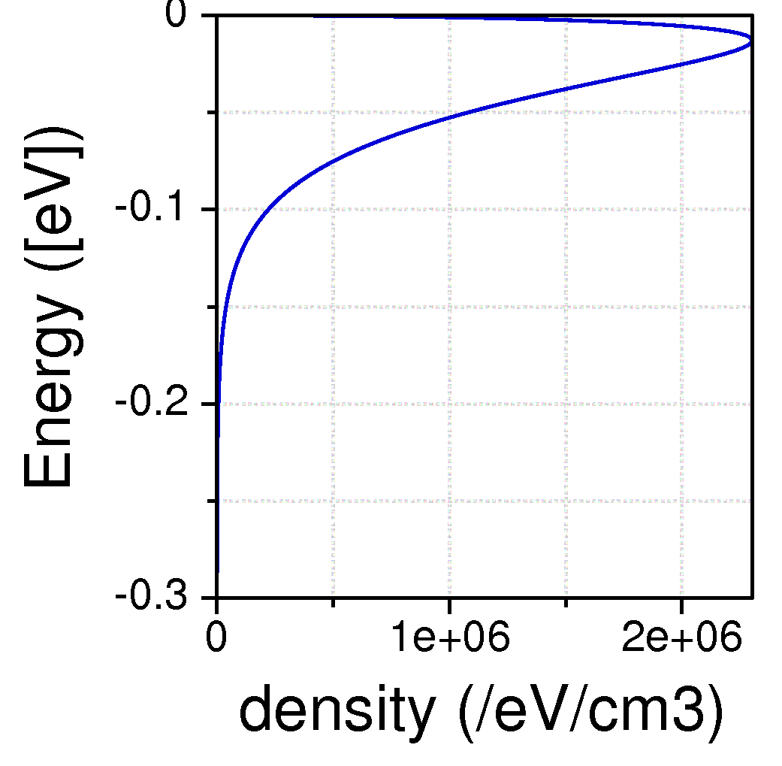
Figure 1 Hole Concentration

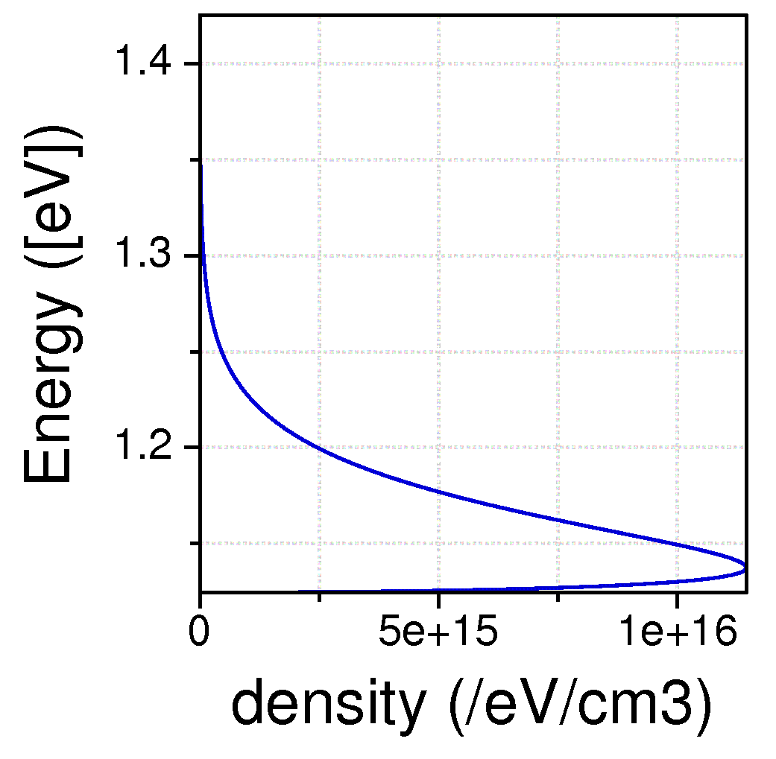
Figure 2 Electron Concentration

