Carrier Statistics – Worked out problems 2
( http://nanohub.org/tools/fermi )

Saumitra R Mehrotra, Dragica Vasileska and Gerhard Klimeck

Q1) Test the accuracy of use Maxwell-Boltzmann (MB) statistics compared to Fermi-Dirac (FD) statistics?
A1) Let us set-up an experiment to test the deviation in hole carrier concentration (P) in Si at T-300K as we move our Fermi level (E_{f}) close to Si valence band edge (E_{v}). We will use MB and FD statistics.

E_{f} -E_{v} | P (/cm³) with MB | P (/cm³) with FD | % difference
6*kT | 5.471x10¹⁶ | 5.465x10¹⁶ | 0.109
5*kT | 1.439x10¹⁷ | 1.435x10¹⁷ | 0.278
4*kT | 3.785x10¹⁷ | 3.757x10¹⁷ | 0.754
3*kT | 9.955x10¹⁷ | 9.768x10¹⁷ | 1.91
2*kT | 2.618x10¹⁸ | 2.494x10¹⁸ | 4.97
1*kT | 6.887x10¹⁸ | 6.116x10¹⁸ | 12.6
0 | 1.811x10¹⁹ | 1.386x10¹⁹ | 30.66

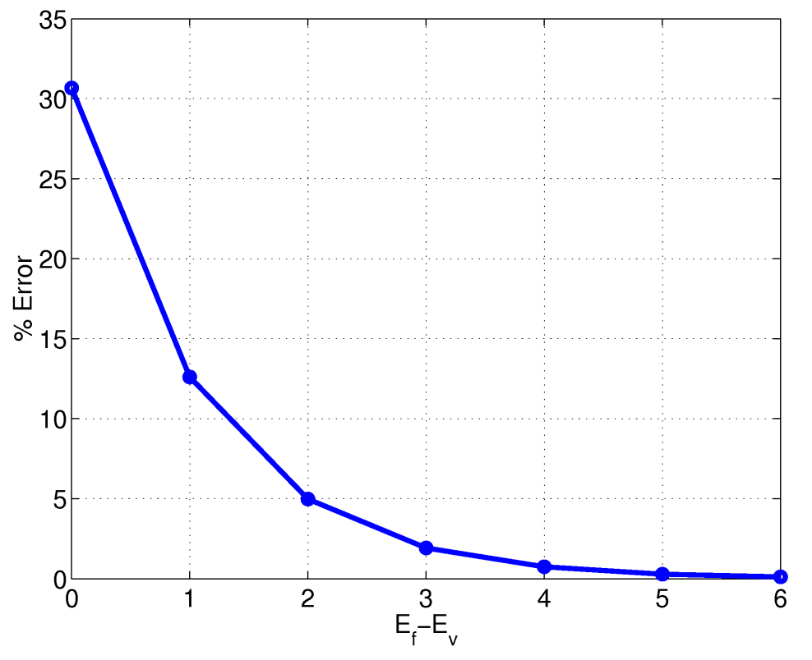
Q2 ) Find the temperature range for which Ge, n-type doped at 10¹⁵/cm³ can operate in extrinsic regime (i.e. n=N_{D}⁺).
A2) Select Ge as the material and choose Fermi-Dirac Statistics. Set donor doping level at 10¹⁵/cm³. Run the temperature sweep.
Select 3D electron/hole density with temperature output plot. It can be deduced from the plot that Ge, n-type doped at 10¹⁵/cm³ remains extrinsic for the range of 180K<T<330K.

