Drift Diffusion Lab – Worked out problems 1
( http://nanohub.org/tools/semi )

Saumitra R Mehrotra, Dragica Vasileska and Gerhard Klimeck

Q1) As shown in figure below, the right half of a 100 µm long Silicon bar is illuminated with light. This light generates G_{L}=10¹⁸/cm³-s electron-hole pairs uniformly throughout 50 µm of right half. G_{L}=0 for left half of the bar. Steady state conditions prevail. The entire bar is doped with N_{D}=10¹⁸/cm³. Set τ_{p}=1ns and T=300 K. Assume finite surface recombination on left end and no recombination on right end.

- What is the diffusion length for minority carriers?
- What is the hole concentration at left end?
- What is the hole concentration at right end?
- Plot Δp(x) for all along the bar.
- Do low level injection conditions prevail?
- How does energy band diagram look like under non-equilibrium conditions?

A1) a) Diffusion length can be calculated as $L=\sqrt{μ*kT*τ}$
For holes here $L\sim \sqrt{450*0.025*{10}^{-9}}=1.06 μm$

b) Left edge is many diffusion lengths from the perturbation hence hole concentration, p₀=n_{i}²/N_{D}=100 /cm³

c) On the right end hole concentration p= p₀+G_{L}τ_{p}
Δp_{r}=100+10¹⁸/cm³-s*10⁻⁹ s = 10⁹ /cm³

d) Excess carrier density plot can be obtained from Drift-Diffusion Lab as shown below.

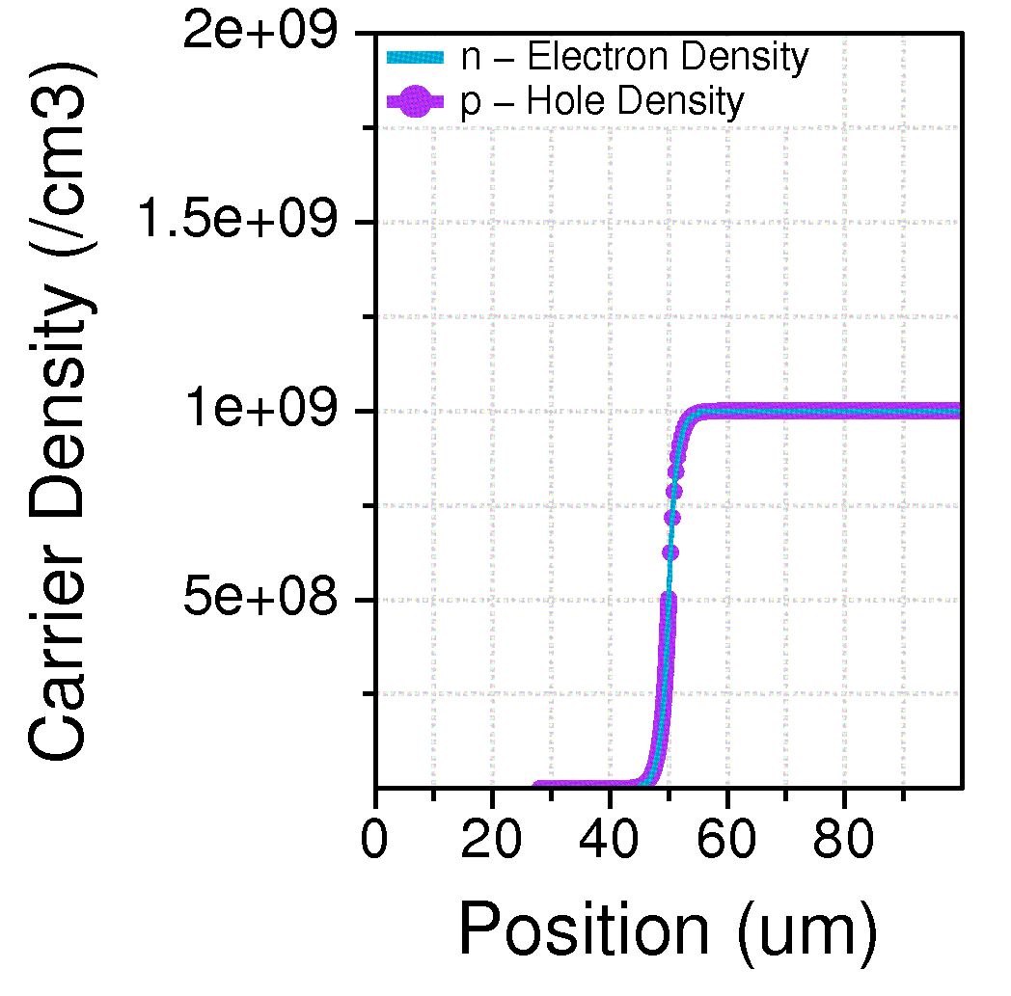

e) We have Δp_{r} << n₀=N_{D}, hence low level injection condition do prevail.
YES.
Also as can be seen in the figure below excess hole concentration is still less than electron doping level.

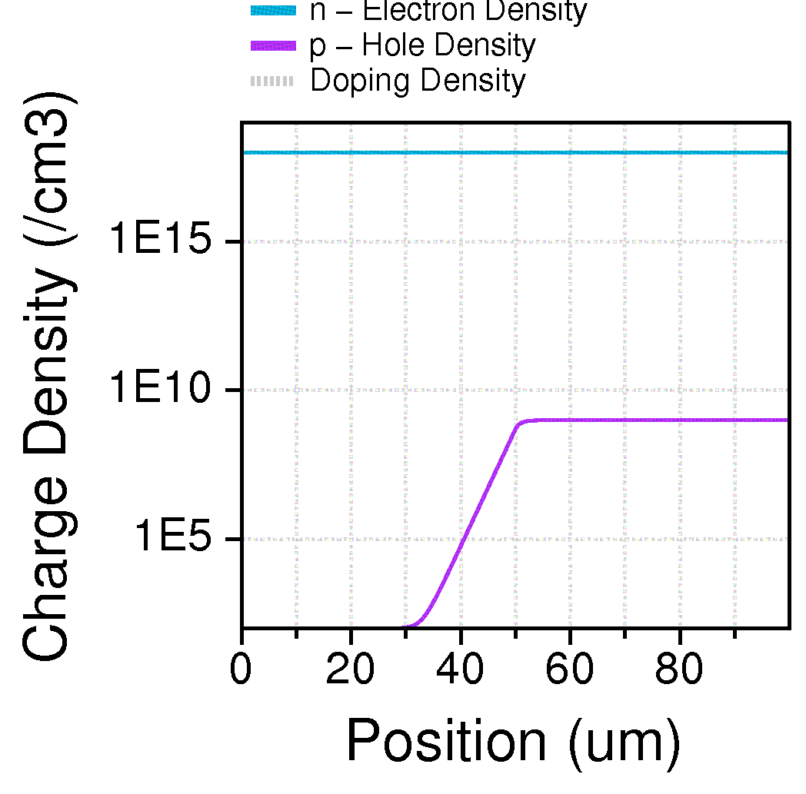

- The energy band diagram under perturbation shows splitting of Fermi level into Electron (F_{n}) and hole quasi Fermi levels. Hole quasi Fermi level (F_{p}) is pushed down due to excess holes on right half of the bar.

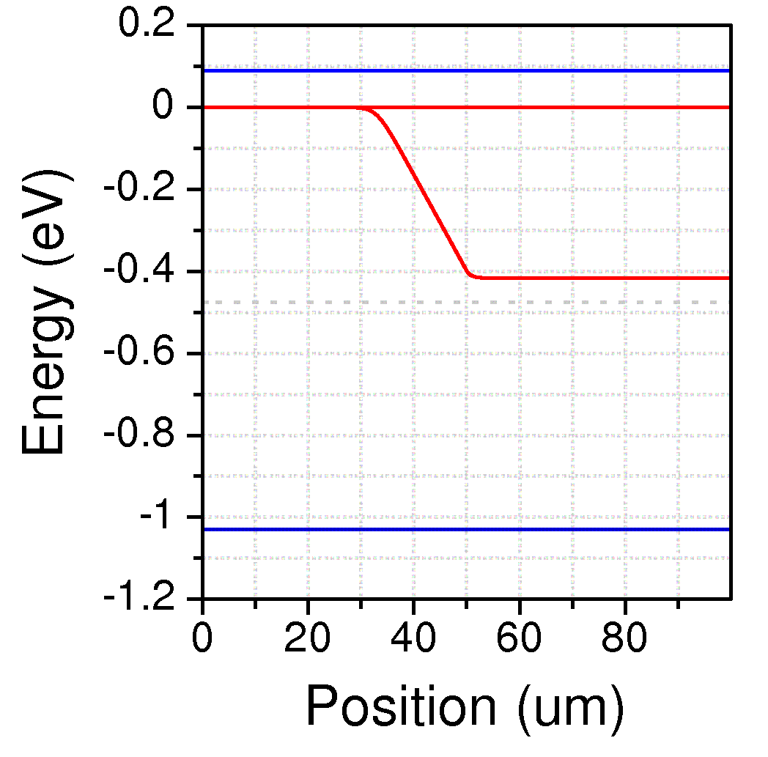
F_{n}
F_{p}

