Drift Diffusion Lab – Worked out problems 2
( http://nanohub.org/tools/semi )

Saumitra R Mehrotra, Dragica Vasileska and Gerhard Klimeck

Q1) Compute concentration dependent electron and hole mobility for Gallium Arsenide (GaAs) and Germanium (Ge).
- Which material has higher electron mobility at doping level of 10¹⁵ cm³?
- Which material has higher hole mobility at doping level of 10¹⁵ cm³?
- Why does mobility reduce at higher doping?

A1) Set up the simulation assuming a semiconductor bar of length, l=10µm. Mobility values can be extracted by applying small amount of bias V~ 0.1V and measuring the current density (J).
Following formula can be then used to extract mobility values.
For electrons: $J_{n}=qnμ_{n}(V/l)$
For holes: $J_{p}=qpμ_{p}(V/l)$
After calculations we obtain the following results,

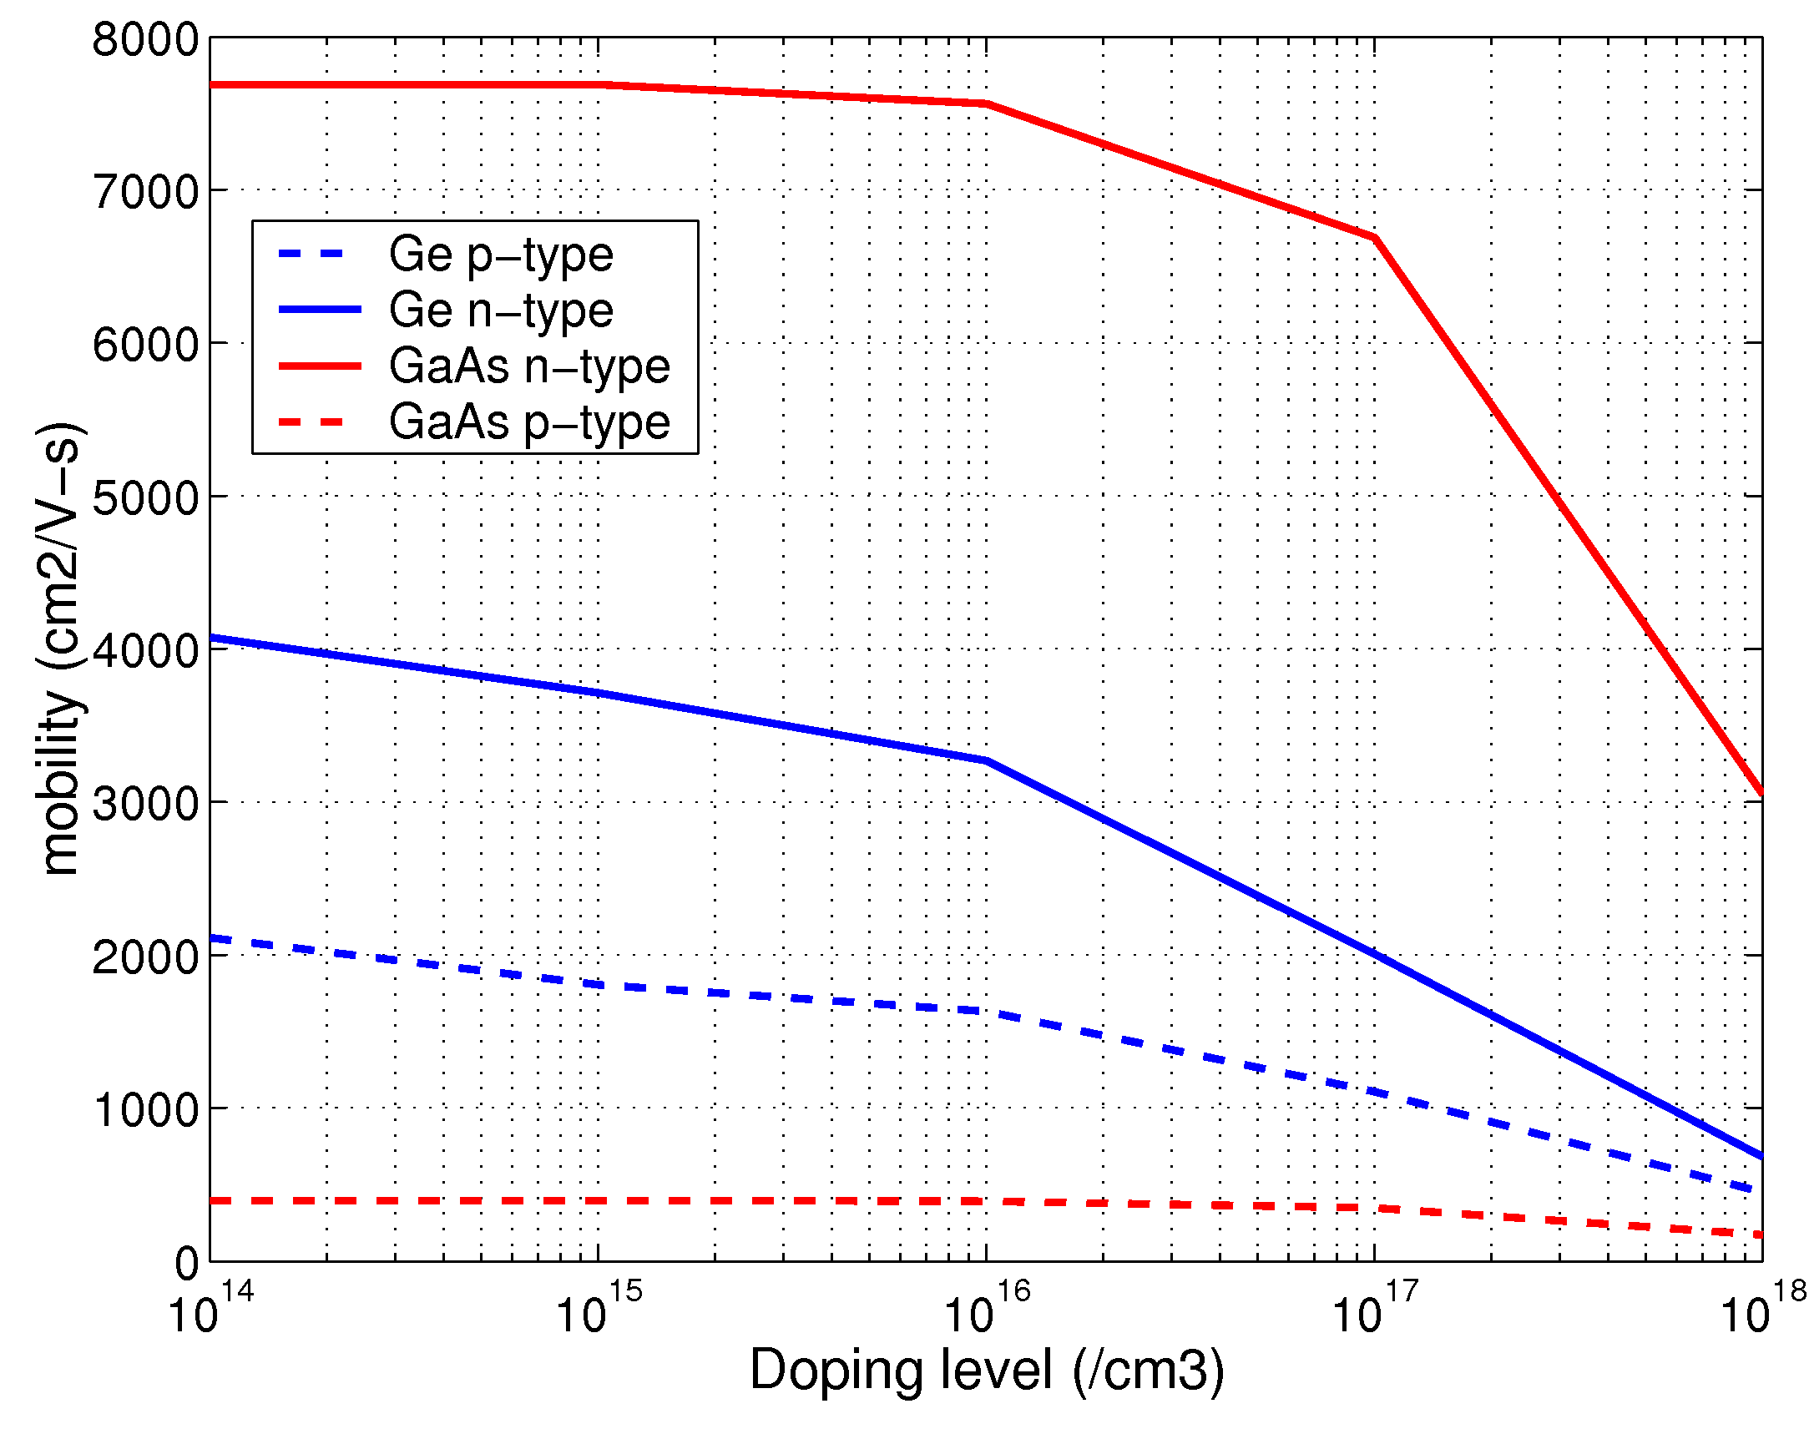

- a) GaAs shows higher electron mobility doping level of 10¹⁵ cm³.

b) Ge shows higher hole mobility at doping level of 10¹⁵ cm³.

c) At higher doping levels scattering due ionized impurities become significant and lead to a reduction in overall mobility value.

