Verification of the validity of MOSFET lab

(<http://nanohub.org/tools/mosfet>)

Saumitra R Mehrotra, Dragica Vasileska & Gerhard Klimeck

**Simulation setup**

We will validate results obtained from MOSFET Lab by comparing with analytical model. Set up a simulation run using the following input parameters

1. Input deck page 1

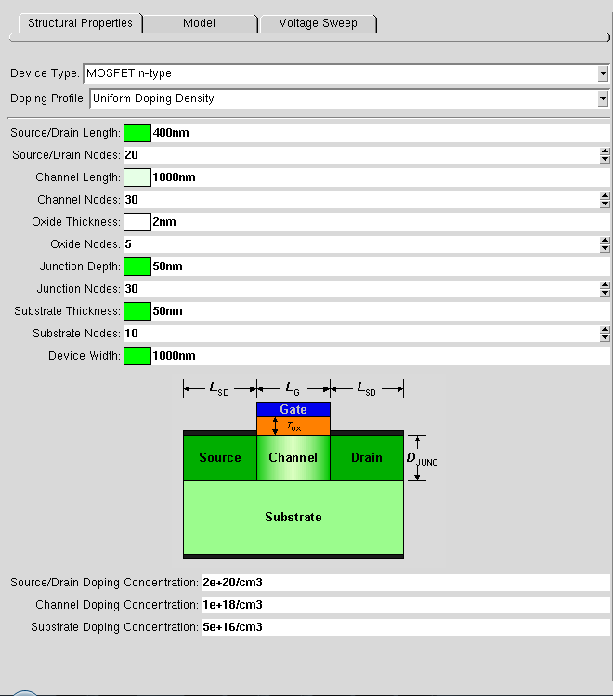,

1. Input deck page 2

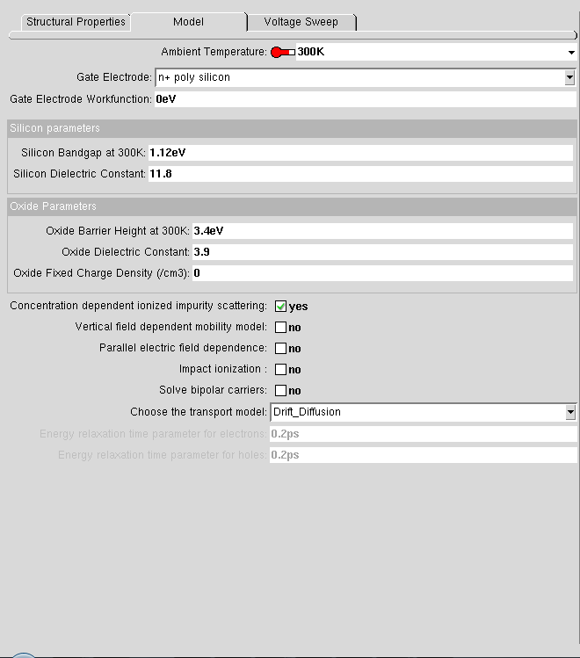

**Simulation Output**

1. Transfer characteristics obtained after running MOSFET tool using above input deck. Estimated threshold voltage from the ID-VG plot, **VT ~ 0.33 V*.***

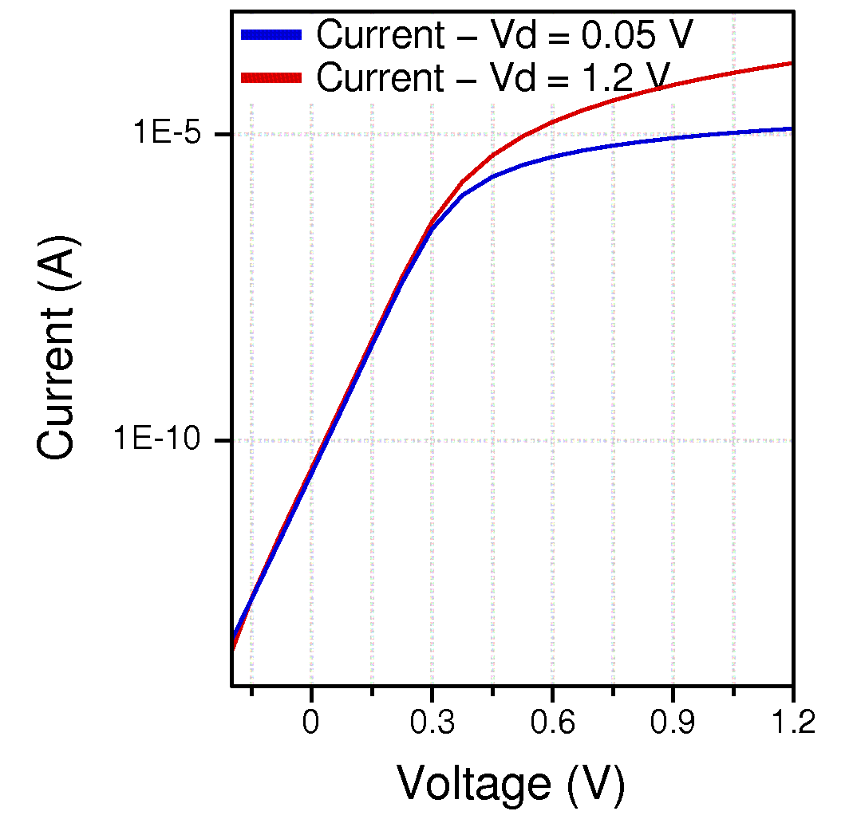

Figure 1 Id-Vg plot from MOSFET tool

1. Output characteristics obtained after running MOSFET tool using above input deck.

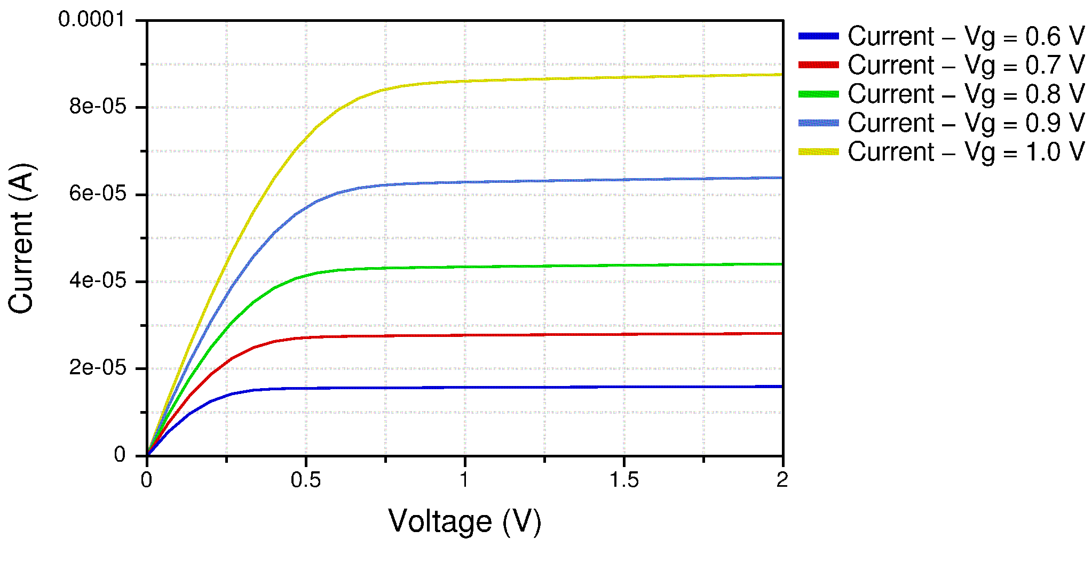

Figure 2 Id-Vd plot from MOSFET tool

**Analytical Verification**

Output characteristic of a bulk MOSFET are computed using Bulk Charge theory (R.F Pierret, SDF pg. 625). Further results from the analytical model were adjusted for parasitic resistance (RSD) to match simulation results. A value of RSD=1000 Ω was used to fit the data. (MATLAB script given at the end)

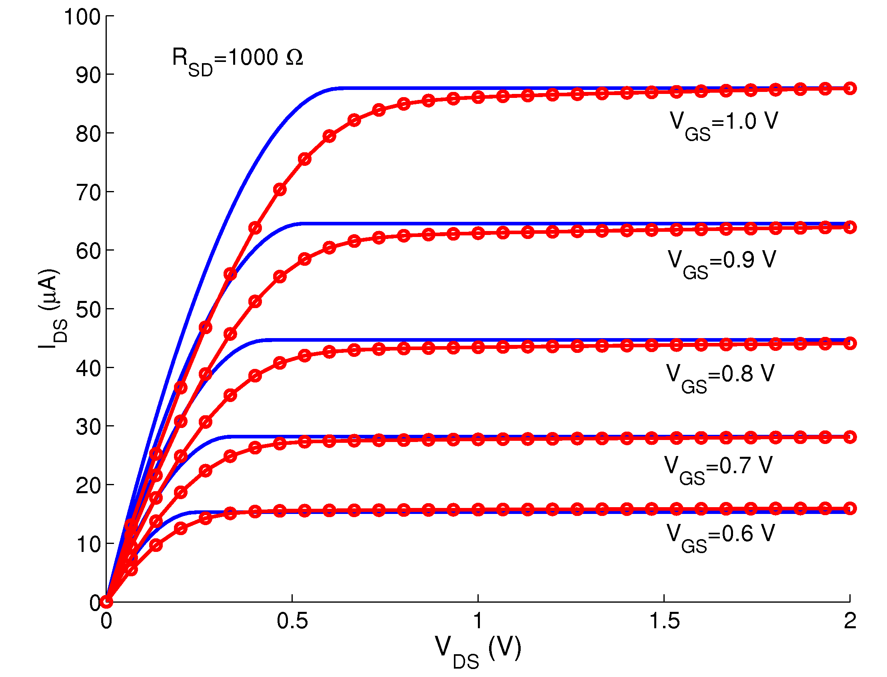

Figure 3 Analytical verification of MOSFET Lab. Analytical model using Bulk-Charge (blue) is used to compare simulation results from MOSFET lab (red)

**MATLAB script used for verification**

% Output characteristic (Id-Vd) computed for a bulk MOSFET using Bulk Charge theory

% Series resistance adjusted to compare with MOSFET Lab (https://nanohub.org/tools/mosfet)

% Author: Saumitra R Mehrotra (Purdue University)

clear all

% Load results from MOSFET Lab

load v1.txt;load v2.txt;load v3.txt;load v4.txt;load v5.txt

hold on

disp(['Start of verification']);

% INPUT

% Threshold voltage

vt=0.33;

% Parasitic Resistance

Rsd=1000; % in Ohms

% CONSTANTS

kT_q=0.02585; q=1.6e-19;

ni=1e16; %in /m3

Ks=11.9;

% Oxide thickness

tox=2e-9; %in m

% Channel length

L=1000e-9; %in m

% Device width

W=1000e-9; %in m

% Oxide dielectric constant

ko=3.9;

eo=8.85e-12; % in F/m

% Gate capacitance

Co=(ko*eo)./tox; % in F/m2

% Channel doping

Na= 1e18*1e6; %in /m3

phiF=(kT_q)*log(Na/ni);

Wt=(sqrt((2*Ks*eo*2*phiF)/(q*Na)));

Vw=(q*Na/Co)*Wt;

% Averaged Mobility for given Na

mu=300e-4; % in m2/Vs

factor=(W*mu*Co)./L;

vg=linspace(0.6,1,5); vd=linspace(0,2,100);

for ii=1:1:length(vg) % VG step loop

for jj=1:1:length(vd) %VD loog

VG1=vg(ii);VD1=vd(jj);

term1=Vw*(sqrt((VG1-vt)./(2*phiF)+ (1+Vw./(4*phiF))^2) - (1+Vw./(4*phiF)));

if (VD1 <= VG1-vt-term1)

term2=(4/3)*Vw*phiF*((1+VD1./(2*phiF)).^1.5-(1+(3*VD1)./(4*phiF)));

id(jj)=factor*((VG1-vt)*VD1-(VD1*VD1/2)-term2);

else

term2=(4/3)*Vw*phiF*((1+(VG1-vt-term1)./(2*phiF)).^1.5-(1+(3*(VG1-vt-term1))./(4*phiF)));

id(jj)=factor*((VG1-vt)*(VG1-vt-term1)-((VG1-vt-term1)*(VG1-vt-term1)/2)-term2);

end

f1=VG1-vg(ii)+id(jj)*Rsd/2;

VG2=vg(ii)-0.01;VD2=vd(jj)-0.01;

term1=Vw*(sqrt((VG2-vt)./(2*phiF)+ (1+Vw./(4*phiF))^2) - (1+Vw./(4*phiF)));

if (VD2 <= VG2-vt-term1)

term2=(4/3)*Vw*phiF*((1+VD2./(2*phiF)).^1.5-(1+(3*VD2)./(4*phiF)));

id(jj)=factor*((VG2-vt)*VD2-(VD2*VD2/2)-term2);

else

term2=(4/3)*Vw*phiF*((1+(VG2-vt-term1)./(2*phiF)).^1.5-(1+(3*(VG2-vt-term1))./(4*phiF)));

id(jj)=factor*((VG2-vt)*(VG2-vt-term1)-((VG2-vt-term1)*(VG2-vt-term1)/2)-term2);

end

f2=VG2-vg(ii)+id(jj)*Rsd/2;

% adjust for Rsd

err=1;id_old=1e7;count=0;

while(err > 1e-4 & count<=50)

VG=VG2-f2*(VG2-VG1)/(f2-f1);

VD=vd(jj)+2*(VG-vg(ii));

term1=Vw*(sqrt((VG-vt)./(2*phiF)+ (1+Vw./(4*phiF))^2) - (1+Vw./(4*phiF)));

if (VD <= VG-vt-term1)

term2=(4/3)*Vw*phiF*((1+VD./(2*phiF)).^1.5-(1+(3*VD)./(4*phiF)));

id(jj)=factor*((VG-vt)*VD-(VD*VD/2)-term2);

else

term2=(4/3)*Vw*phiF*((1+(VG-vt-term1)./(2*phiF)).^1.5-(1+(3*(VG-vt-term1))./(4*phiF)));

id(jj)=factor*((VG-vt)*(VG-vt-term1)-((VG-vt-term1)*(VG-vt-term1)/2)-term2);

end

f=VG-vg(ii)+id(jj)*Rsd/2; f2=f1;VG2=VG1; f1=f;VG1=VG;

err=abs(VG2-VG1);

count=count+1;

end

% end Rsd adjusting

end

plot(vd,id*1e6,'b'); % convert in microAmps

end

plot(v1(:,1),v1(:,2)*1e6,'ro-');

plot(v2(:,1),v2(:,2)*1e6,'ro-');

plot(v3(:,1),v3(:,2)*1e6,'ro-');

plot(v4(:,1),v4(:,2)*1e6,'ro-');

plot(v5(:,1),v5(:,2)*1e6,'ro-');

disp(['End of verification']);