BJT Lab – Worked out problem
( http://nanohub.org/tools/bjt )

Saumitra R Mehrotra

Q1) Simulate the npn BJT transistor as shown in Fig. 1 using ‘BJT Lab’ at nanoHUB and calculate the following characteristics,
- Early Voltage.
- β_{DC} parameter while operating at i_{base}=2µA V_{CC}=20V and R_{LOAD}=200kΩ.
- Output Resistance.
- Specify the active and saturation region in the output characteristic curve.

10µm
5µm
Collector
Emitter
Base
Emitter
N_{D} = 1e19/cm³
τ = 0.1µs
N_{A} = 1e16/cm³
τ = 1µs
N_{D} = 1e15/cm³
τ = 0.1µs
25µm
1µm
4µm

Answer)
Simulation the above BJT design using BJT lab gives the following output characteristics.

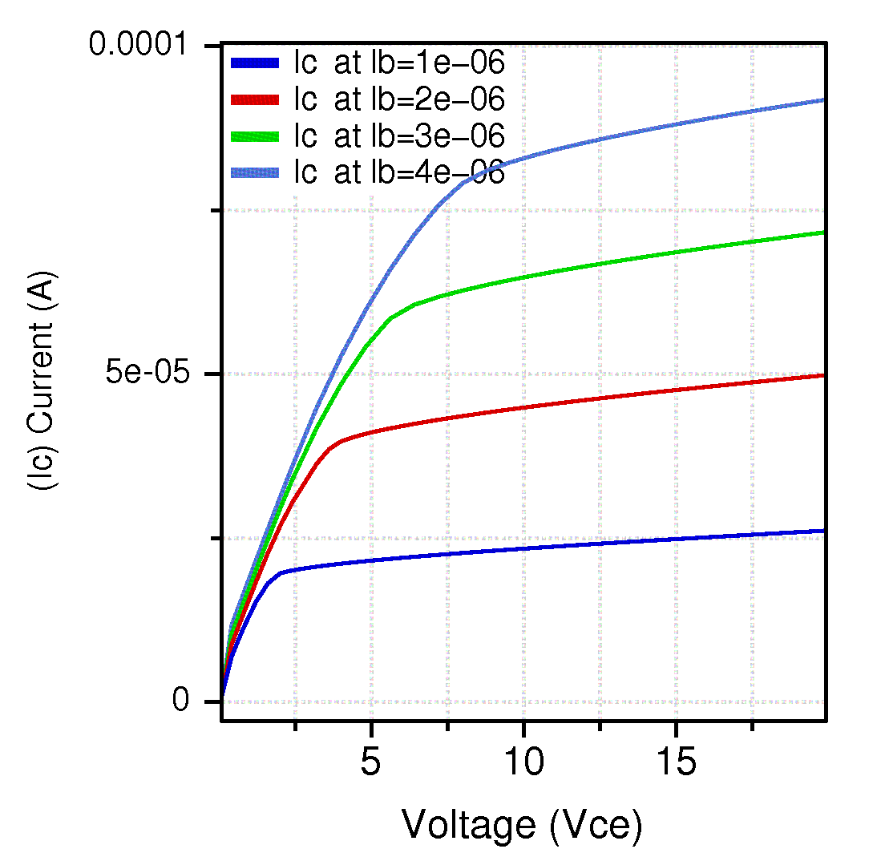

(a) Early voltage can be estimated by extrapolating the linear regimes of the output curves as shown below. Early voltage is found to be V_{Early} ~ 80 V

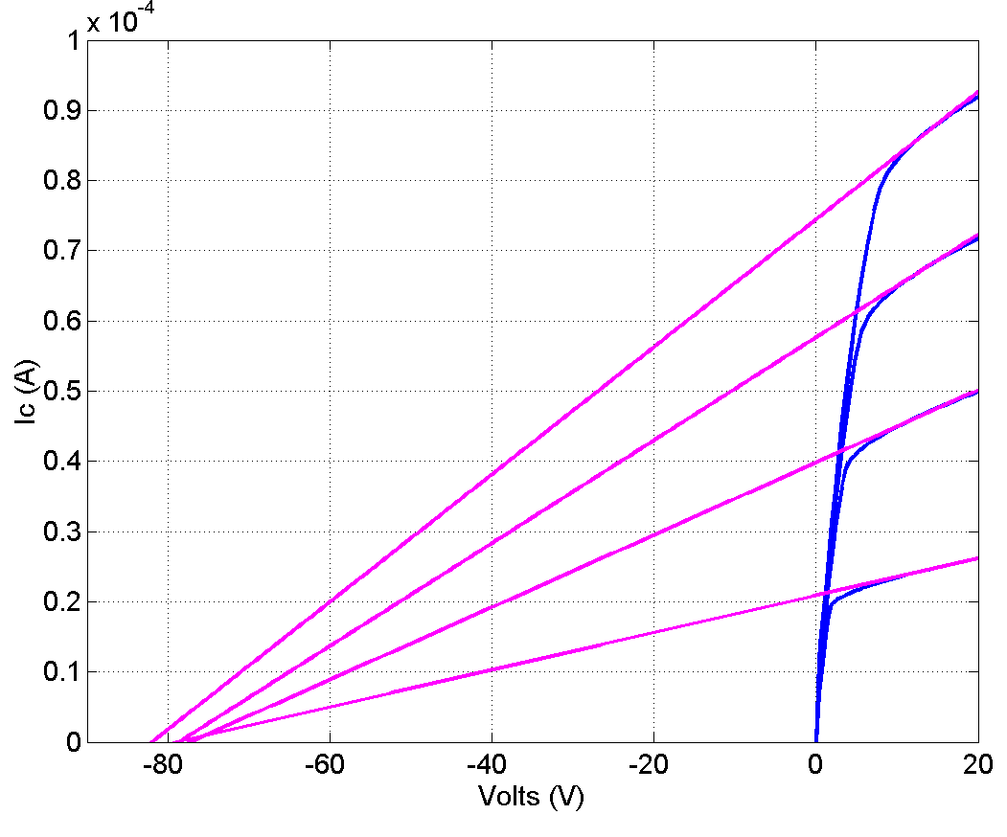
(c) β_{DC} can be calculated by plotting a load line to obtain the operating point as shown below. β_{DC}=i_{c}/i_{b}= 45.4µA/2µA= 22.7

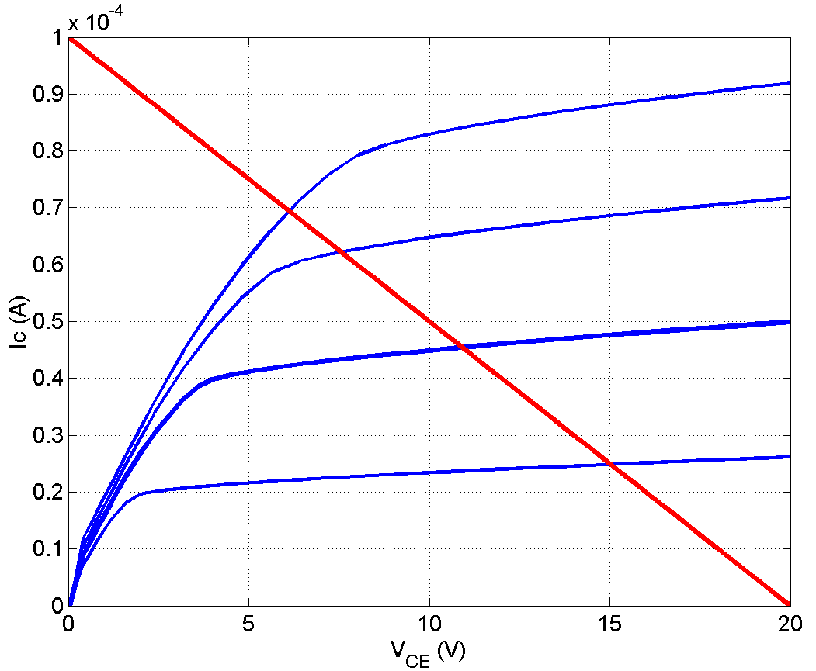
Operating point

(c) Output resistance at the operating point r_{o}= (V_{early}+V_{CE})/ i_{c} ~ (80+11)/45.4µA
or r_{o} ~ 2 MΩ.

(d) Active and Saturation regions are marked on the Ic-V_{CE} plot below.

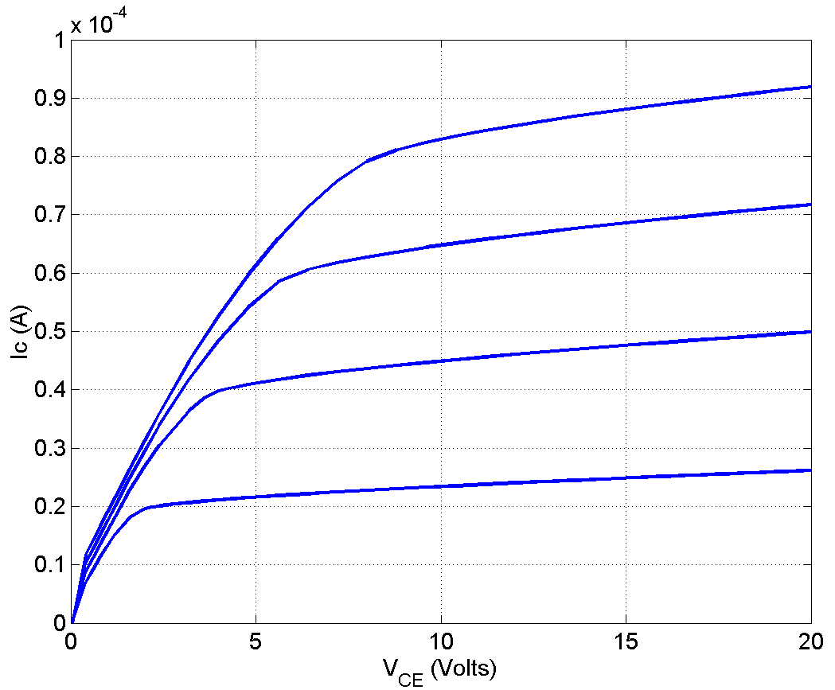
Saturation Region
Active Region

