MODULE 1: Material Profile–Graphene
Rachel Altovar and Susan P. Gentry
University of California, Davis

“Curiosity-driven research. Something random, simple, maybe a bit weird--even ridiculous…Without it, there are no discoveries” – Andre Geim

This module and subsequent three modules will lead up to the experimental resource on nanoHUB “Turning Fruit Juice into Graphene Quantum Dots” as explained on the resource overview page: https://nanohub.org/resources/34255.

LEARNING OBJECTIVES
- Learn about the fascinating material graphene
- Explore graphene’s structure and properties
- Investigate prospective applications for graphene in the future
- Introduce the types of properties of engineering materials

BACKGROUND

Graphene
Carbon: One of the building blocks of life. One of the most fascinating elements in the periodic table for its multi-use and purposes. Commonly found as the material graphite, which consists of stacked sheets of carbon with a hexagonal structure. Can also be found as a diamond, which is a different form of carbon created under high pressure. [1]

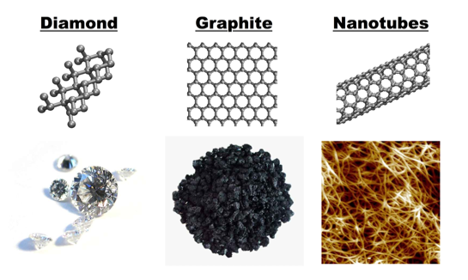
Figure 1. Three forms of carbon: diamond, graphite, and carbon nanotubes. These will be discussed in this and subsequent modules [2].

What do you get when you have a single atomic layer of carbon? A two-dimensional (2D) crystalline material, graphene. Produced, isolated, identified, and characterized by Andre K. Geim and Konstantin S. Novoselov at the University of Manchester, UK, they won the Nobel Prize in Physics in 2010. Figure 2 shows the form of graphene.

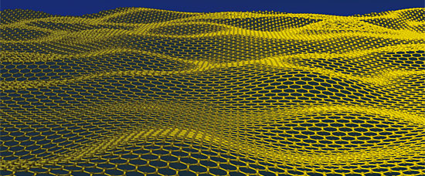
Figure 2. 2D graphene, only one atom thick [3].

One millimeter of graphite actually consists of three million layers of graphene stacked on top of one another. Layers of graphite are weakly held together and are very easy to tear off and separate. When you write with a pencil, it is possible that only a single layer of atoms, graphene, ends up on the paper.

Essentially, this is what happened when Andre Geim and Konstantin Novoselov used adhesive tape to rip off thin flakes from a larger piece of graphite in a scientific and experimental manner. At first they got flakes consisting of many layers of graphene. After repeating the tapetrick ten to twenty times, the flakes of graphene got thinner and thinner. Geim and Novoselov then had to find a way to get graphene away from the thick layers of graphite and other pieces of carbon. So what could they do? The scientists decided to attach the flakes of graphene to a plate of oxidized silicon, which is the standard working material in the semiconductor industry. (Semiconductors will be explained later in MODULE 4).

When the plate was placed in a microscope, they could see a rainbow of colors, like what you see when oil is spilled into water. From these colors the number of graphene layers in the flakes could be determined. The thickness of the underlying layer of silicon dioxide was crucial for revealing the graphene. Under a microscope, a two-dimensional crystalline material (graphene) exists.

But what makes graphene such an interesting material? It has remarkable mechanical and electrical properties: it was found to be stronger than steel and very stretchable! Two differing ideals.

A completely new material, not only the thinnest ever, but also the strongest. It performs as well as copper in terms of electricity. As a conductor of heat, it performs better than any known material. It is completely transparent. Not even helium, the smallest gas atom can pass through it because of its density! [4] To understand the properties of graphene, we will need to know how the atoms are arranged and interact with each other. These atom-atom interactions are governed by the field of quantum mechanics (see MODULE 4).

Now what does graphene actually look like? Graphene is a single layer of carbon packed in a hexagonal lattice, like a honeycomb as you can see in Figure 1. (Crystal structures will be discussed in MODULE 3 of this investigative, interactive material profile). Graphene is a perfectly regular network of carbon with only two dimensions, width and length. The basic unit of this pattern consists of six carbon atoms joined together chemically. The distance between each carbon is 0.142 nm. Woah, that’s a very small distance! (MODULE 2 discusses the effect of different sizes and their properties).

As discussed earlier, graphite is the most basic material found in nature. When taken apart, graphite sheets become graphene. A popular application of graphene is for carbon nanotubes, which are rolled layers of graphene. Their ends may be half spherical as you can see in Figure 3.

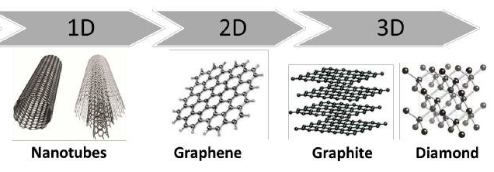
Figure 3. Structural representation of the various forms of carbon [5].

Why do we care about any of this? Well for starters, as stated earlier, graphene has some really cool properties, which makes it useful for several different applications. Graphene is a thin, mechanically strong, transparent and flexible conductor. Its conductivity can be modified over a large range either chemically or electrically. This material can be used for electronics that use high frequencies, like cell phones. In recent years, it has become more possible to fabricate large sheets of graphene. This is helpful for using graphene as a transparent conductor where it can be used as a touch screen, light panel, or solar cell. Flexible electronics and gas sensors are other applications. New types of composite materials have also been developed that use graphene for its great strength and weight, which could be used for satellites and aircrafts.

Material Properties

Since this is the first module in this series of lessons, let’s briefly discuss material properties which include mechanical and electrical properties. The scientific definition of material properties is the “size, shape, density of the particles, and their intrinsic mechanical properties (Young’s modulus, yield stress, fracture toughness, etc.)” [6]. What does that mean though? Those are a lot of big words…. Let’s break it down further.

There are several types of properties of engineering materials (which we sort of touched on). These properties include physical, chemical, thermal, electrical, magnetic, optical, and mechanical properties [7]. Physical properties correspond to the things that we normally think of and the characteristics that easily come to mind when trying to describe a material. This includes density, color, size, and shape. Chemical properties relate to a chemical reaction within a material or substance. Thermal properties are observed when heat passes through it and play an important role into the physical properties of a material as well. One important thermal property is melting point. In terms of mechanical properties this could mean toughness, hardness, brittleness, malleability, and ductility. All these properties will be explained in the APPENDIX. More complicated (and still significant) material properties are electrical properties, magnetic properties, and optical properties. For more interest and information on these three properties please refer to the APPENDIX for this module.

Now that we’ve discussed the different properties, let’s reference graphite, graphene, and diamond as examples of how properties change in different materials. Remember that graphite, graphene, and diamond will have very similar properties because they are all made of carbon, but there are key differences between the three materials. These distinct properties come from the fact that the atoms are arranged differently in each material. This arrangement of atoms will be discussed more in depth in MODULE 3 about structures.[8] MODULE 2, will display the different properties of graphene, graphite, and diamond in a chart and also ties into why size is important.

REFERENCES
[1] The Royal Swedish Academy of Sciences. (2010). “Graphene”, Nobel Prize, The Royal Swedish Academy of Sciences. https://www.nobelprize.org/uploads/2018/06/advanced-physicsprize2010.pdf
[2] Valentin, Amanda, Steve Cranford. (2010). “Adhesion of Carbon Nanotubes”. MIT Laboratory of Atomistic and Molecular Mechanics. http://web.mit.edu/mbuehler/www/SIMS/Adhesion%20of%20Carbon%20Nanotube.html
http://web.mit.edu/mbuehler/www/SIMS/Adhesion%20of%20Carbon%20Nanotube.html
[3] Meyer, Jannik. (2009). Science vol. 324.
[4] Bergström, Lars, Per Delsing et al. (2010). “Graphene- the perfect atomic lattice”, Nobel Prize, The Royal Swedish Academy of Sciences. https://www.nobelprize.org/uploads/2018/06/popular-physicsprize2010.pdf
[5] Srivatsa, Thushar. (2017). “Graphene Based surface coatings on ceramic membranes for water desalination”. https://www.researchgate.net/publication/323915130_Graphene_Based_surface_coatings_on_ceramic_membranes_for_water_desalination
[6] Peukert, Wolfgang, Doris Segets, Lukas Pflug, et al. (2015). “Chapter One – Unified Design Strategies for Particulate Products”, Mesoscale Modeling in Chemical Engineering Part I.
[7] Dixit, Avdhesh. (2018). “Types of Properties of Engineering Materials”. https://madhavuniversity.edu.in/types-of-properties-of-engg-materials.html#:~:text=Electrical%20Properties%20of%20engineering%20materials,resistance%2C%20dielectric%20strength%20and%20thermoelectricity.
[8] Clark, Jim. (2019). “14.4A: Graphite and Diamond – Structure and Properties”, Map: Inorganic Chemistry (Housecroft). https://chem.libretexts.org/Bookshelves/Inorganic_Chemistry/Map%3A_Inorganic_Chemistry_(Housecroft)/14%3A_The_Group_14_Elements/14.04%3A_Allotropes_of_Carbon/14.4A%3A_Graphite_and_Diamond_-_Structure_and_Properties

ACTIVITY
Pencil, Paper, and Sticky Tape
Level of Difficulty: Beginner
Notes: May require getting fingers a tad dirty…
Materials:
- Lined or white piece of paper (any type of paper will work this is just a suggestion for the best results, if you have scrap paper this would work great by helping the environment ☺)
- #2 Pencil (any type of pencil will work; a wooden pencil works the best though!)
- Clear tape (Scotch or generic)
- Clean and dry fingers!!!

Procedure:
- Lay the piece of paper on a flat surface.
- Begin by rubbing your pencil back and forth in a small area of this piece of paper. This could be any type of solid shape (for example a square, circle, triangle, heart, etc.). Make sure that this shape is pretty dark.
- Using a clean and dry finger, rub it over the shape that you just created with your pencil for a few seconds. The pencil will transfer to your finger.
- Place your finger onto the sticky tape (the sticky side of the tape).
- Flip the tape over and stick it onto an empty space on your piece of paper.
- Observe the fingerprint created by the pencil and tape. Leave the initial fingerprint you created alone.
- On a separate space on that same piece of paper, repeat Steps 3-5 (make sure to use a clean and dry finger every single time- not the same finger), three to four more times (or as many times as you’d like). This time overlap your fingerprints in different directions to create an asymmetrical overlapping pattern (try not to put the fingerprints directly on top of one another).

Adapted from: https://holduponheart.co.uk/pages/fingerprint-instructions

Questions:
- What did you just create?
- How does it relate to graphene and the experiment Nobel Prize winners Andre K. Geim and Konstantin S. Novoselov did to understand graphene?
- Think about the relationship between graphite and graphene. In the region that overlaps in Step 7 with the overlapping fingerprints, what material would this most represent? Why?

CONCLUSION
In this module, the material graphene was introduced and discussed with a complementary activity with household objects to show how graphene relates to everyday life. The different types of properties of engineering materials were also explained and described. This module will begin its journey to lead up to the experimental resource on nanoHUB “Turning Fruit Juice into Graphene Quantum Dots”.

Key Takeaway: As you begin to think about (new) materials of the future, how can we be excited about learning?

“Make People Laugh First and Think Second” – Andre Geim

APPENDIX
In the module, we discussed and glossed over the many properties that materials can have. Here in the APPENDIX, we will go more in-depth with the topics and concepts mentioned in the BACKGROUND.

Continuing from the “Material Properties” in the BACKGROUND section, we left off discussing electrical properties, magnetic properties, and optical properties. These properties are some of the more important differences that make graphene such an impactful material (they can be quite difficult to understand without studying them completely).
- Electrical properties: a material’s ability to conduct electrical current. These include properties such as resistivity and conductivity to name a few.
- Magnetic properties: a material’s response to a magnetic field, specifically the interactions with the electrons in the material.
- Optical properties: a material’s response to incident light or other forms of radiation which can be forms of transmission, reflection, and absorption.

From the explanations of all the groups of material properties, you can probably tell by now that there are many properties that comprise these categories. Some of these properties that were mentioned in the module: density, toughness, hardness, brittleness, malleability, ductility, conductivity.
- Density: one of the most fundamental physical properties of any material. The relationship between mass per unit volume.
- Toughness: a characteristic of a material that relates to its response to sudden blows or shocks [1].
- Hardness: resistance to being permanently deformed or bent [1].
- Brittleness: failure by sudden fracture and the absence of ductility [1].
- Ductility: a material’s ability to change shape (deform) usually by stretching along its length [1].
- Malleability: a material’s ability to be reshaped in all directions without failure [1].
- Conductivity: a measure of how easily a material allows electrical current to flow through [1].
For a more comprehensive guide of all the different properties of materials that exist, we recommend reviewing Ref. [1] from ASM, a society for materials engineers.

REFERENCES
[1] ASM Materials Education Foundation. 2010). “Properties of materials: more than physical and chemical”, ASM.
https://www.asminternational.org/documents/10192/1942078/typesofproperties.pdf

