CHEM 870 Adelstein, Spring 2020

Tutorial 2: Exploring Nano-Hub – Ionization energies and missing correlation

Goal: The goal of these activities is to explore more capabilities of Nano-Hub, including calculating the ionization energy. In addition, you will learn to estimate the missing correlation energy in *ab-initio* Hartree-Fock calculations.

To get credit for doing this tutorial, there are a number of activities (underlined) that you must complete and submit your answers/work. **Tasks** or results to submit are indicated with bold.

Activity 1: We are going to “build” our own molecule so that we can simulate the He atom.

First: Switch on Advanced Options to get more tabs/control!

It does not make sense to calculate the PES, Geometry Optimization, or Normal Mode Analysis for the He atom. However, we are going to use Geometry Optimization to determine the ionization energy.

**Task i**: Describe why one cannot calculate the above three properties for a He atom.

We are going to edit the H2 molecule to simulate He.

Use Geometric Input to edit the H2 molecule. Change the 1st atom to a He and the 2nd atom to DA (dummy atom). It doesn’t matter what values you put for the x,y,z coordinates.

Below is what your screen should look like.

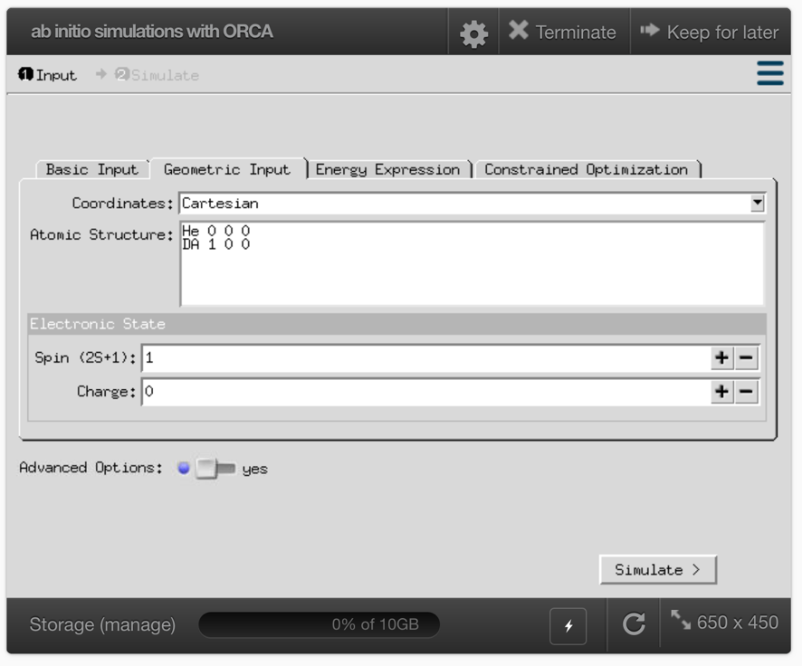

**Task ii**: What should the spin be on the He atom? (What should S equal?) If you don’t remember, look it up on the internet or a quantum chemistry book.

**Task iii**: Record the default values in the Energy Expression tab.

Method:

Basis Set:

Activity 2: Press simulate! Check you have Geometry Optimization & Cartesian Coordinates.

As before, you can download the output, which you should do.

**Task iv:**

1. What is the total energy of the helium atom in kcal/mol, Hartrees, and eV?
2. What is the ionization energy predicted from this calculation? (see below)

Remember IE = EHe+ - EHe

You’ll need to remember/look up the value for EHe+, which can be known exactly because there is only one electron to consider.

The experimental ionization energy is 0.9033 Hartrees.

1. Is the value you calculated smaller or larger than the experimental value?

The difference is due to a number of factors, including the missing correlation between electrons.

1. Explain why the missing correlation makes your value higher or lower than the experimental value:

The default basis set is not terrible; SVP uses polarized valence double-zeta functions. Let’s see what value we get using a polarized valence triple-zeta basis set. We’ll learn more about basis sets later. Change the basis set in the Energy Expression Tab.

Activity 3: Change the basis set to TZVP and determine if the energy decreases.

**Task v:**  Is the TZVP better than the SVP basis set? Justify your answer by explaining how the ionization energy potential changes and compares to the experimental value.

Activity 4: Change the basis set to cc-pVTZ, which stands for correlation-consistent polarized triple-zeta. These basis sets try to improve the energy by including more polarized basis functions, but not actually calculating correlation, which can be done to improve accuracy. Read section 6.2.3 of Cramer’s “Essential of Computational Chemistry: Theories and Models”.

**Task vi:** Did the cc-pVTZ improve the accuracy of the He atom compared to the TZVP?