ECE 440: Solid State Electronic Devices
Fall 2008

Section E: MWF 1:00-1:50PM • Everitt 163 • Prof. Eric Pop

Course Mechanics:
- Three lecture/discussion meetings per week
- Four sections in parallel: same syllabus, homeworks, exams
- Final grade = Tests + 0.15 × (1 – Tests/100) × Homeworks
where Tests = 0.25 Midterm + 0.40 Quizzes + 0.35 Final
- Midterm → Tues, Oct 14, 7-9pm in MSEB 100
- Quizzes → approx. 6 in-class, 20 min. each, lowest dropped
- Homeworks, solutions, other resources on web site:
  - http://courses.ece.uiuc.edu/ece440

- Prof. Eric Pop, OH Monday 10-11 am, MNTL 2258
- TA: Jihan Kim, OH Friday 2-4 pm, Beckman 3253
- Feel free to attend any/all lectures and office hours
- Additional office hours by appointment

Please read Syllabus handout
Questions:
- Why “solid state”?
- Why “electronics”?
- Why are we here?

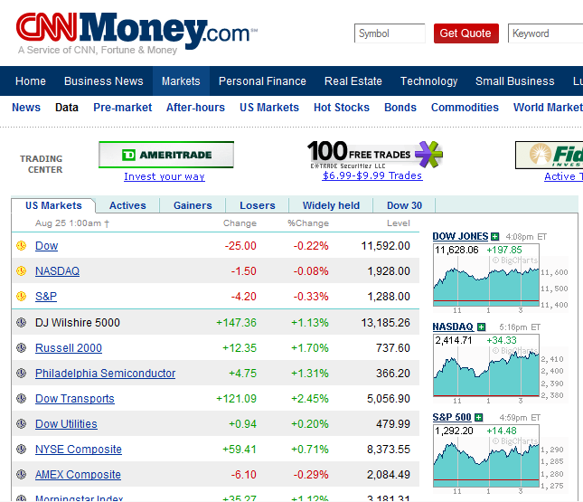

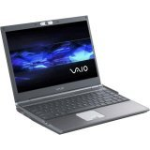
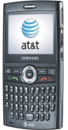
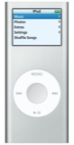
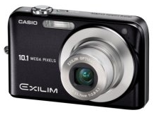

What’s at the heart of it all?

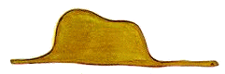

What can we get out of it?
The Abacus, Ancient Digital Memory
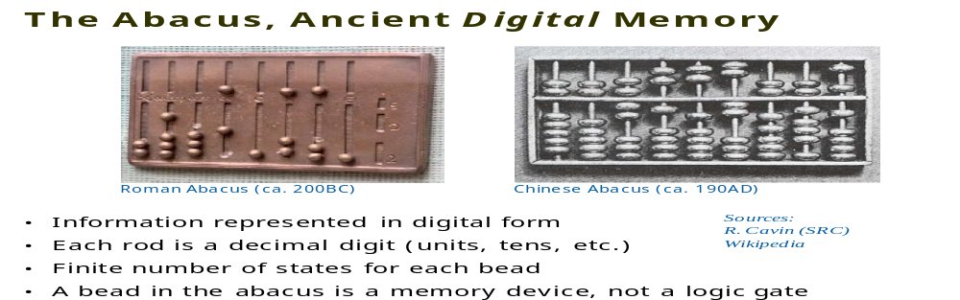
- Information represented in digital form
- Each rod is a decimal digit (units, tens, etc.)
- A bead is a memory device, not a logic gate

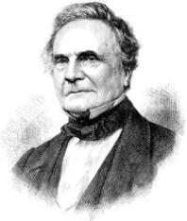
An Early Mechanical Computer
Charles Babbage (Wikipedia)
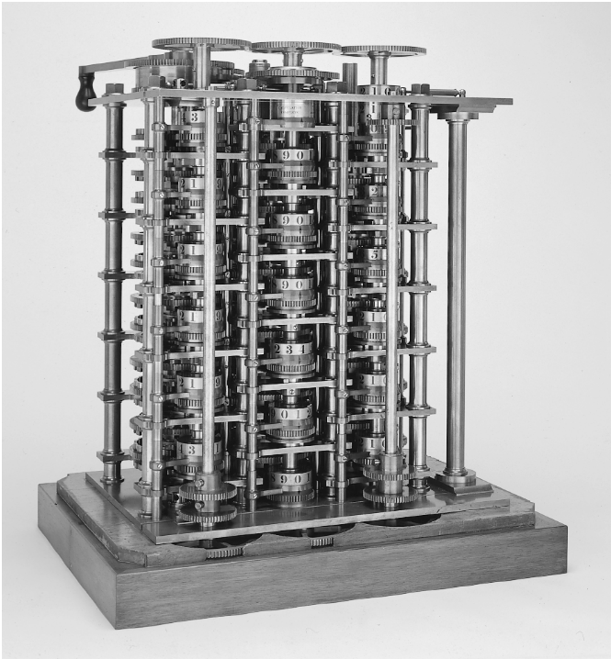
The Babbage
Difference Engine (1832)
25,000 parts

Sources: R. Cavin (SRC), Wikipedia
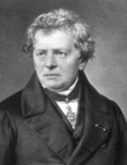
Ohm’s law: V = I × R
Georg Ohm, 1827

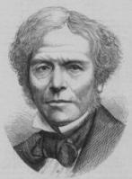
Semiconductors are not metals
Michael Faraday, 1834
Semiconductor resistance decreases with temperature

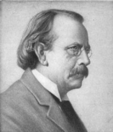
Discovery of the electron
J. J. Thomson, 1897
(measured only charge/mass ratio)
“To the electron – may it never be of any use to anybody.” – J. J. Thomson's favorite toast

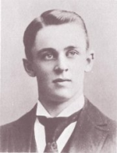
Measuring the electron charge: 1.6 × 10⁻¹⁹ C
Robert Millikan, oil drops, 1909

Sources: Wikipedia, http://www.pbs.org/transistor
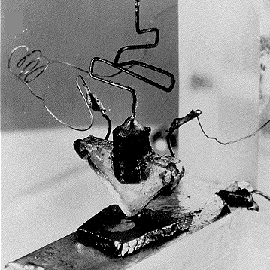
ENIAC: The first electronic computer (1946)
30 tons, including ~20,000 vacuum tubes, relays
Punch card inputs, ~5 kHz speed
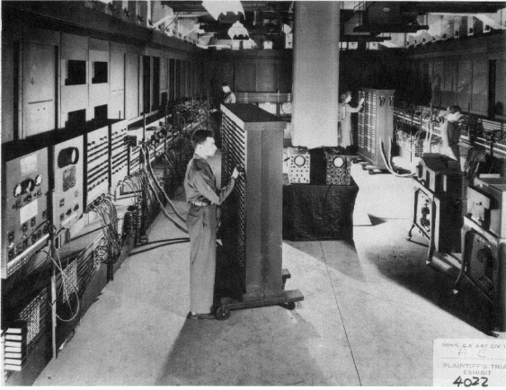
It failed ~every five days

Note: ILLIAC @ UIUC
5 tons, 2800 vacuum tubes
64k memory (1952)

Modern age:
The first semiconductor transistor
AT&T Bell Labs, Dec 1947
J. Bardeen, W. Brattain, W. Shockley
Germanium base, gold foil contacts

Note: ILLIAC II @ UIUC
Built with discrete transistors (1962)

Sources: Wikipedia, http://www.pbs.org/transistor

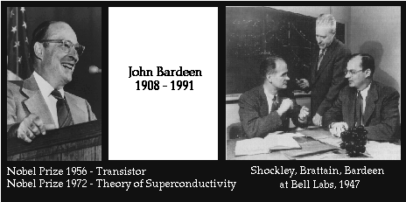

AT&T Bell Labs 1945-1951
Univ. Illinois ECE & Physics 1951-1991

The way I provided the name, was to think of what the device did. And at that time, it was supposed to be the dual of the vacuum tube. The vacuum tube had transconductance, so the transistor would have “transresistance.” And the name should fit in with the names of other devices, such as varistor and thermistor. And… I suggested the name “transistor.”
– John R. Pierce AT&T Bell Labs, 1948
First transistor radio Regency TR-1 (1954)
Built with four discrete transistors

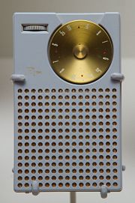

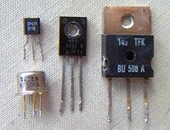

Integrated circuits fabricate all transistors and metal interconnects on the same piece of silicon
- Jack Kilby UIUC’47, patent TI’1959, Nobel prize 2000
- Robert Noyce 1961, co-founder of Fairchild, then Intel
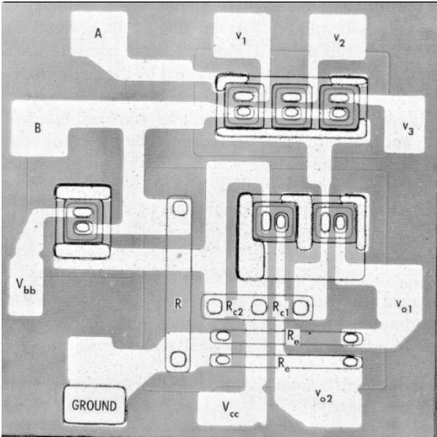
The first microprocessor, Intel 4004 (1971)
2250 transistors, 740 kHz operation

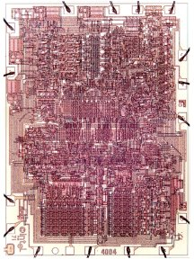
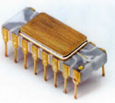

F.F. = Federico Faggin
(designer)

- Comparable computational power with ENIAC
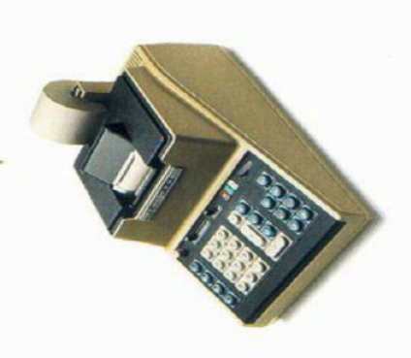
- Built on 2” and then 3” wafers (vs. 12” today)
- 10 μm line width (vs. 65 nm today)
- 4-bit bus width
- Used in… the Busicom Calculator:

Followed by 8008 (8-bit), 8080, 8086
Then 80286, 80386, 80486 = i486 (1989, 0.8 μm lines)
Pentium, II, III, Itanium, IV, Celeron, Dual-Core, Core 2…
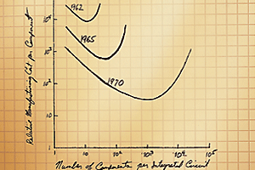
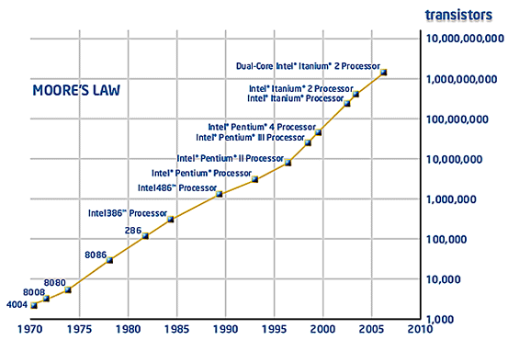
Gordon Moore’s “Law”
≈ doubling circuit density every 1.5-2 yrs

1965

Source: http://www.intel.com
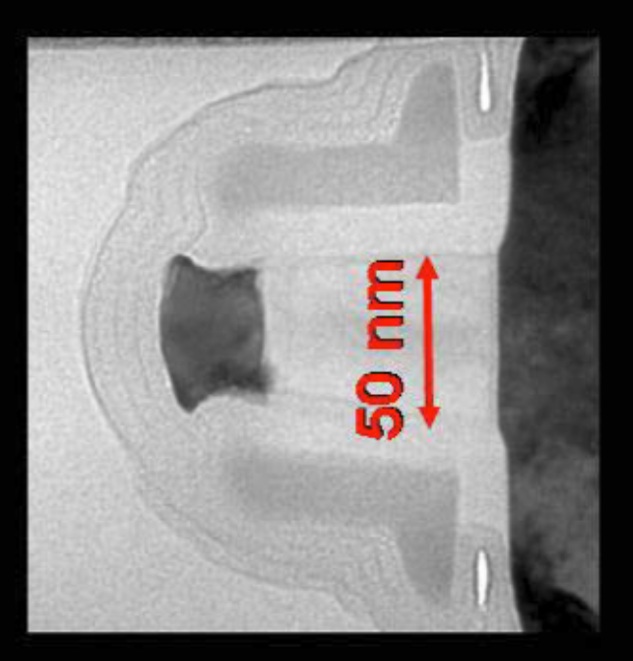
Transistor size scaling:
Influenza virus
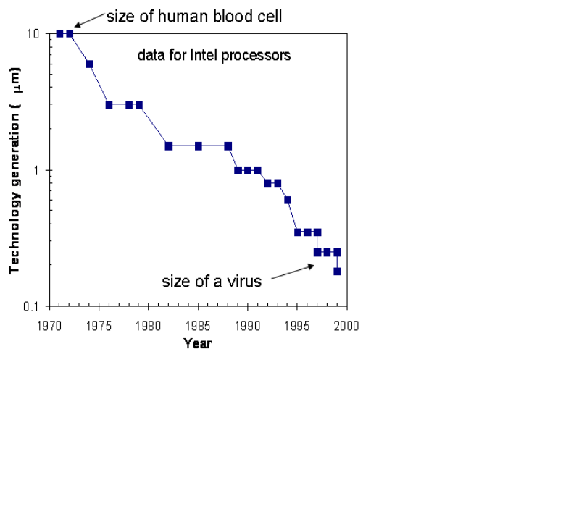
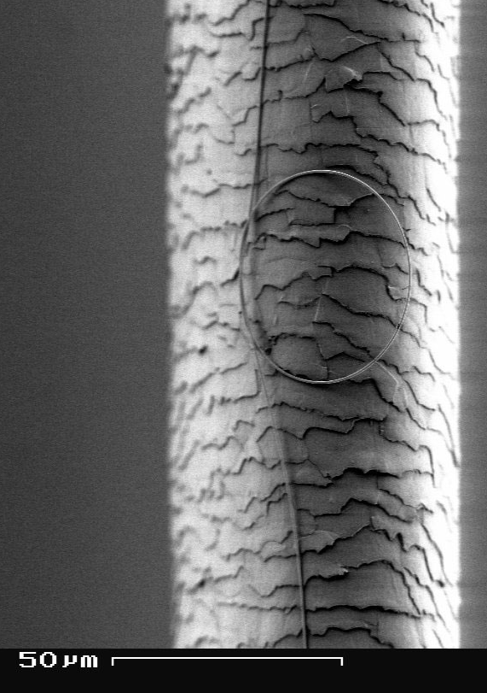

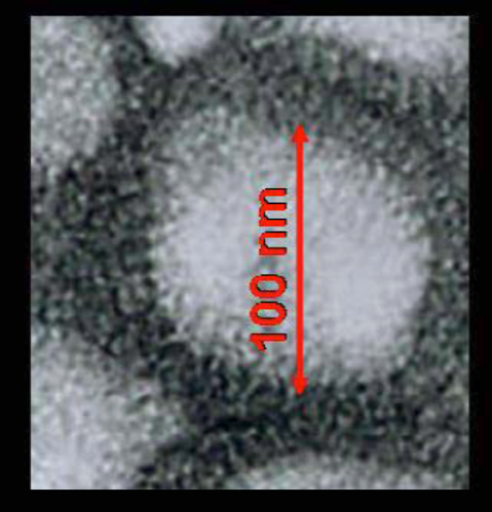

“90 nm” technology
in my laptop CPU today

Sources: NSF, Intel
Some unintended (negative) side-effects of scaling:
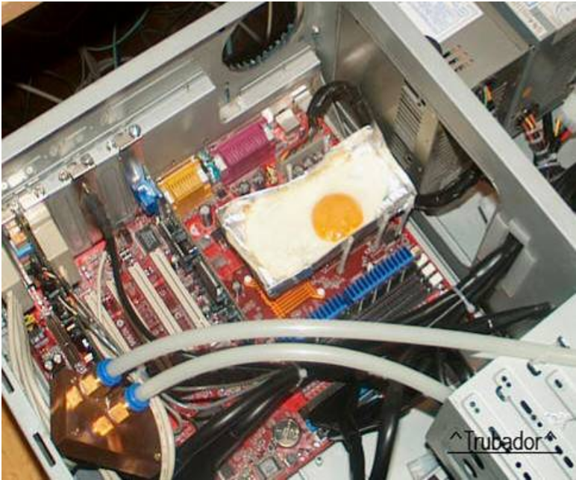
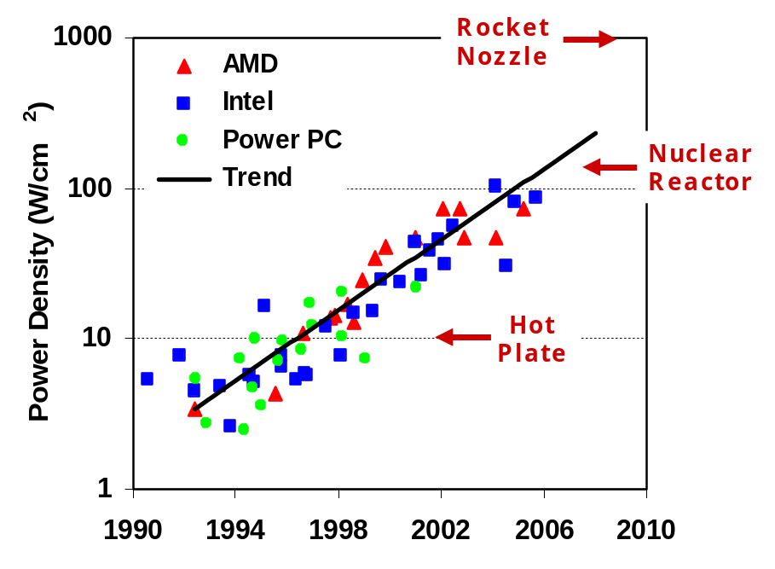

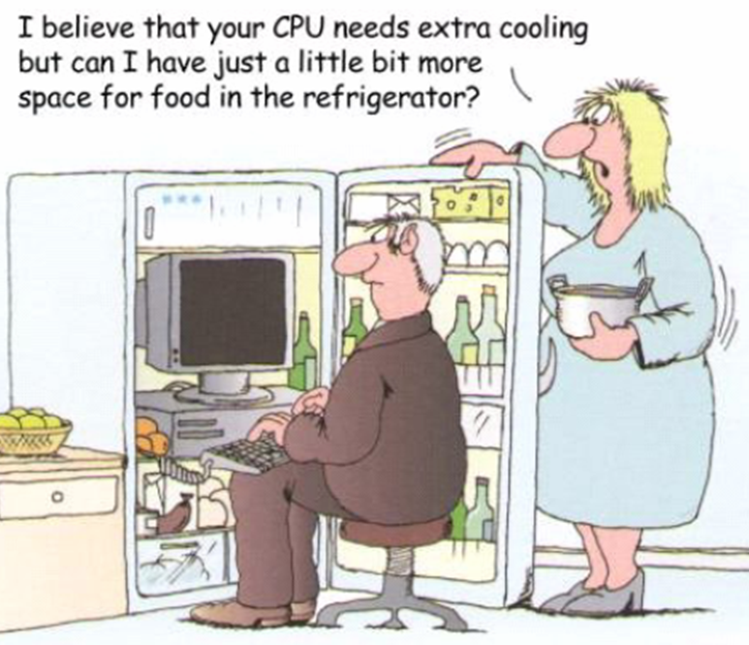
Take off the cover of a microprocessor.
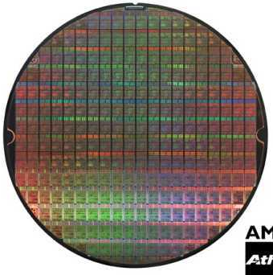
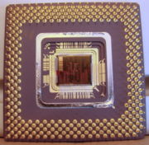

Full wafer (100s of dies)

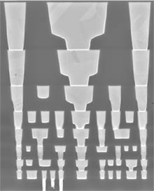
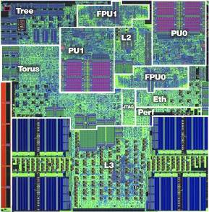
Packaged die

Cross-section
Single transistor
Why semiconductors?
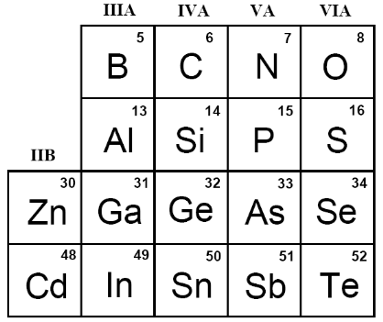
- vs. conductors or insulators

- Elemental vs. compound

Why (usually) crystalline?
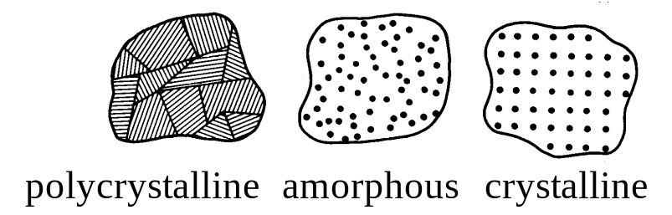

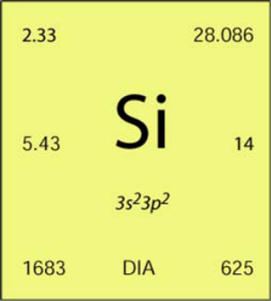
Why silicon?

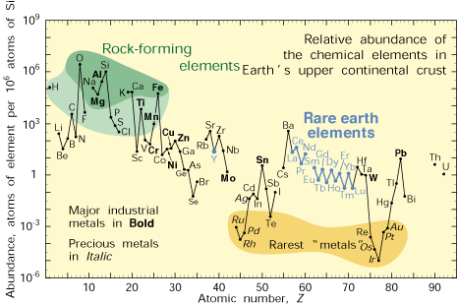
Why the (CMOS) transistor?

- Transistor = switch
- Technology is very scalable (Moore’s Law)
- CMOS = complementary metal-oxide-semiconductor
- Fabrication technology = reproducible on extremely large scales
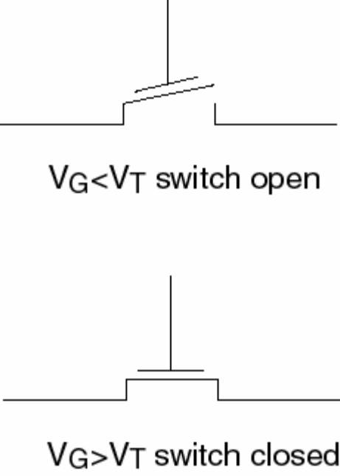
- Circuit engineering
- Design abstractions

What do we learn in ECE 440?
(ECE 444)
Processing
- Zone refining
- Epitaxial growth
- Photolithography
- Resist (positive/negative)
- Encapsulation (CVD, sputtering)
- Ion etching
- Ion implantation and diffusion
Physics

ECE 440
Devices
- P-N diode
- Schottky barrier
- Bipolar junction transistor
- Metal-oxide-semiconductor field-effect transistor (MOSFET)
- Solar cells
- Photodiodes
Materials
- Fundamental properties
- Crystal structure
- Charge carriers
- Energy bands
- Optical absorption (direct/indirect)
- Electrical properties (drift/diffusion)
- Mobility and diffusion

Circuits

One shouldn’t work on semiconductors, that is a filthy mess; who knows if they really exist!
Wolfgang Pauli, 1931
(Nobel Prize, Physics, 1945)

