MOSCAP Lab – Worked out problems 1
(http://nanohub.org/tools/moscap)

Saumitra R Mehrotra, Dragica Vasileska and Gerhard Klimeck

Q1) A MOS-C is maintained at T=300K, oxide thickness x₀=0.1 µm and the Si doping is N_{A}=10¹⁵/cm³. Use n+ poly gate material. Answer the following questions:
- Plot high frequency and low frequency C-V characteristics. What is the estimated V_{T} for this device?
- Plot Energy band diagram along with charge density near the semiconductor-oxide interface for the following biases points: Accumulation, near V_{T} and Inversion region of C-V.
- Compute analytically W_{T} and compare with numerical data.
- Plot Surface potential v/s Gate bias for the MOS-C.

A1) a)
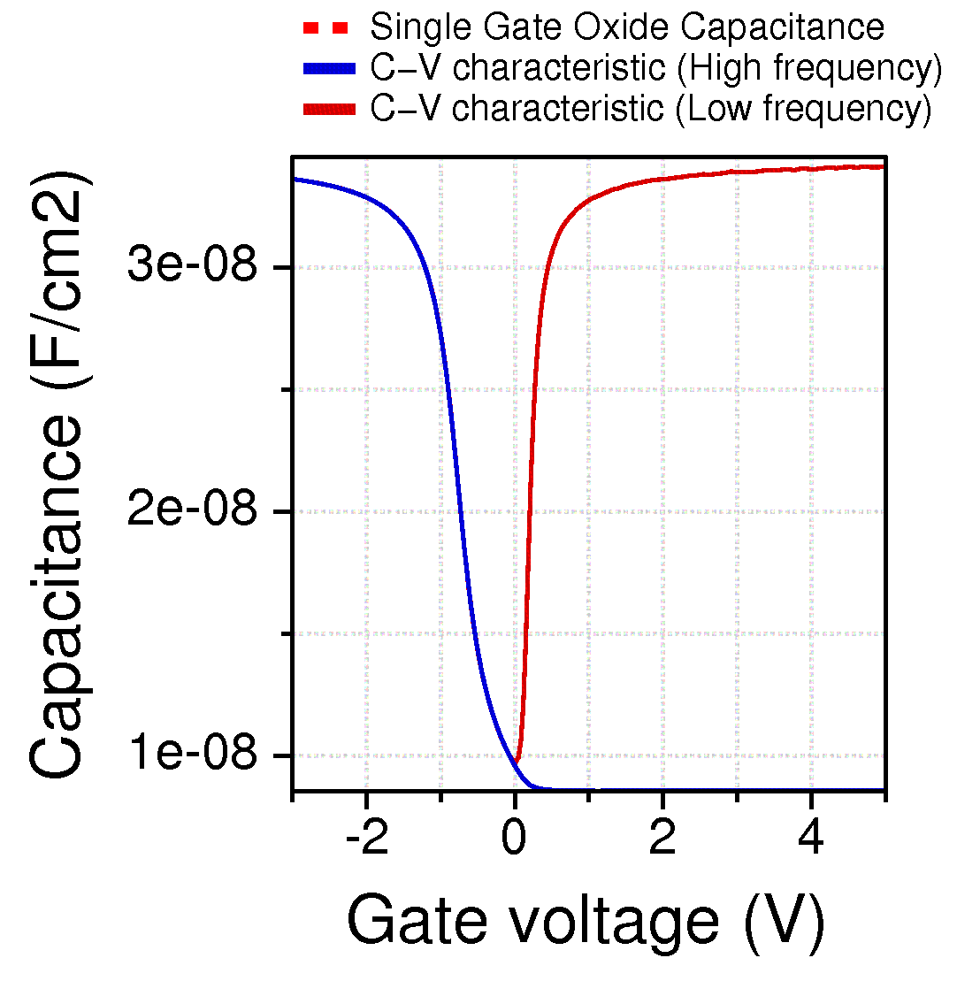

Estimated threshold voltage from the CV figure , V_{T}= 0V.

b) (i) Accumulation (V_{G}=-2V)

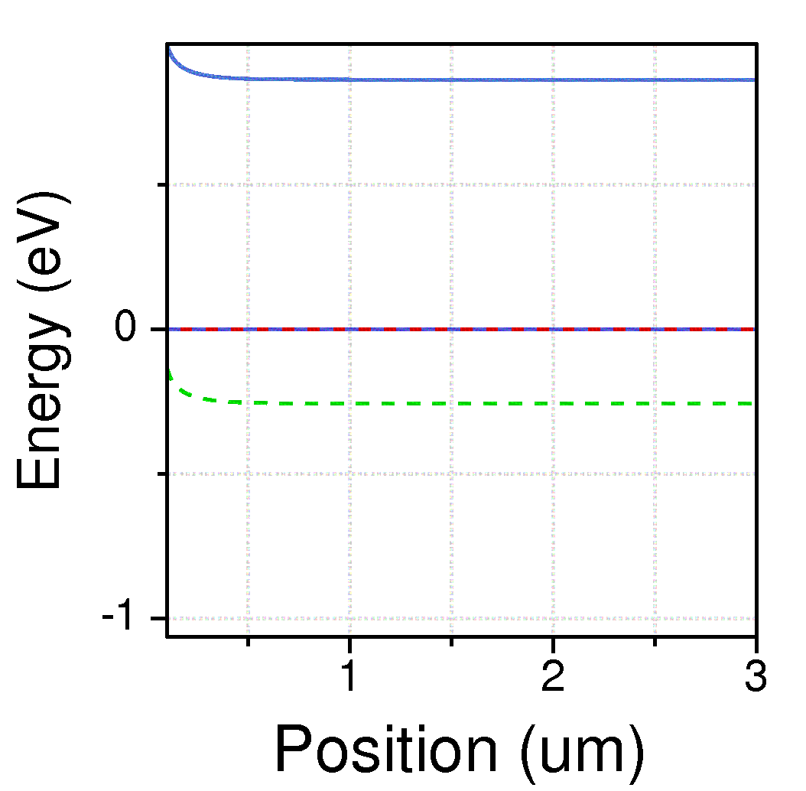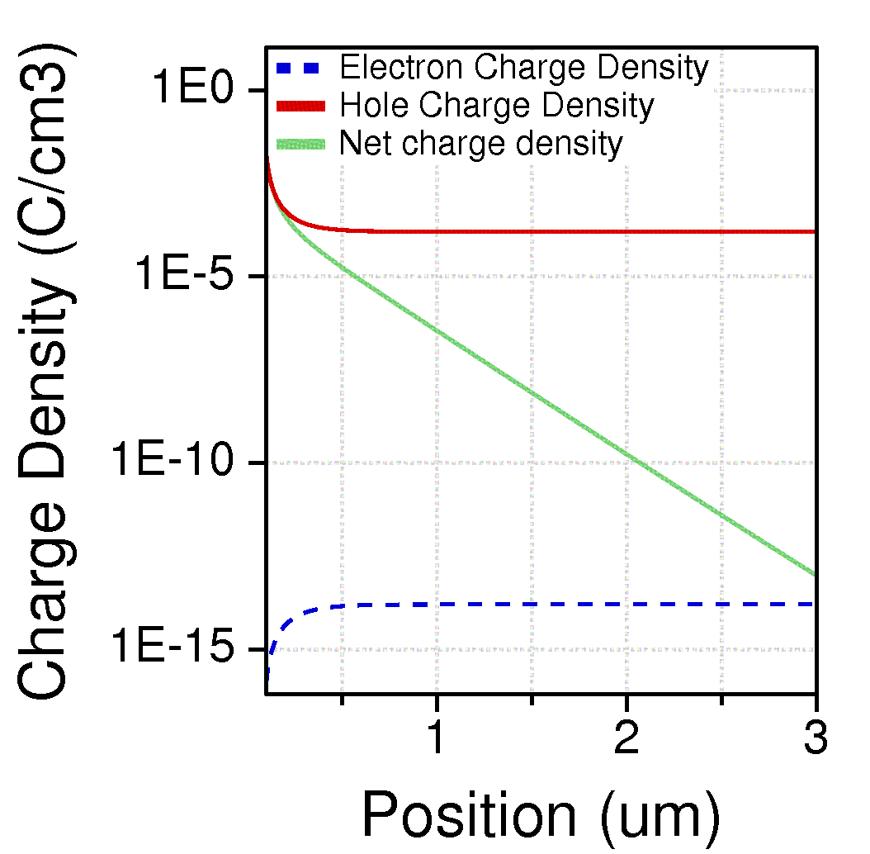

(ii) Near threshold voltage V_{T} (V_{G}=0V)

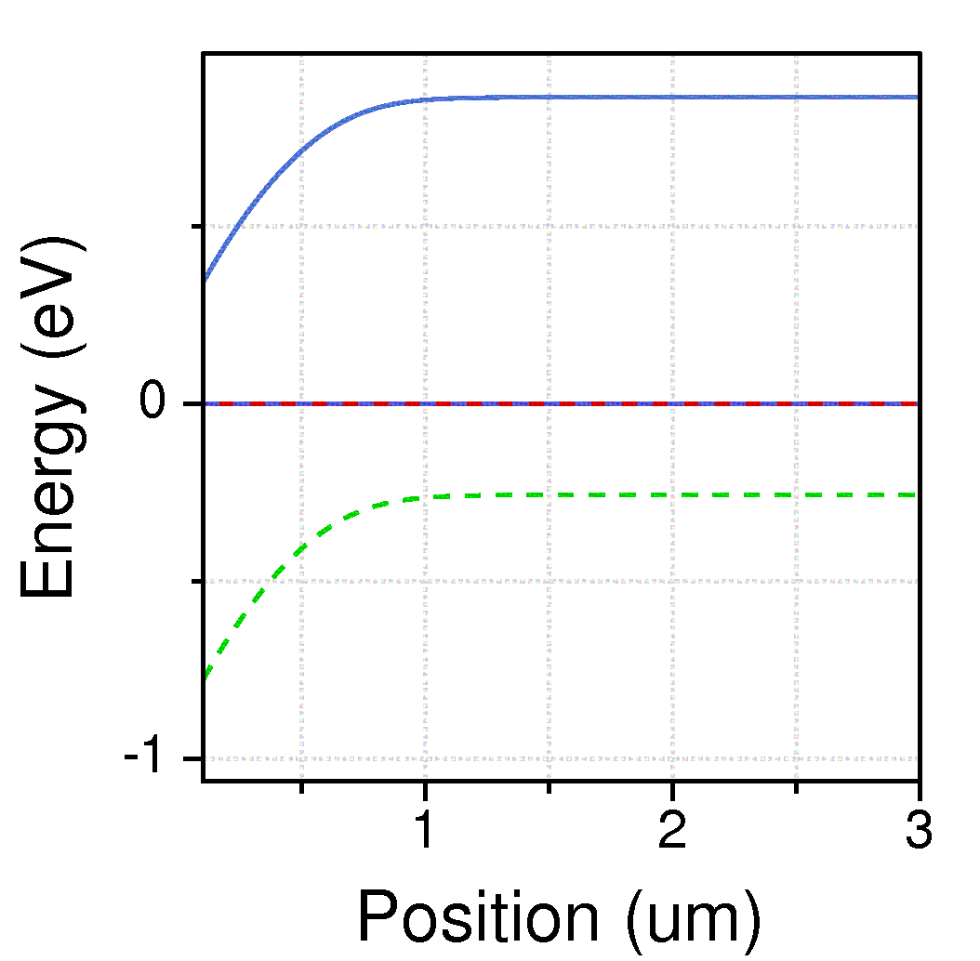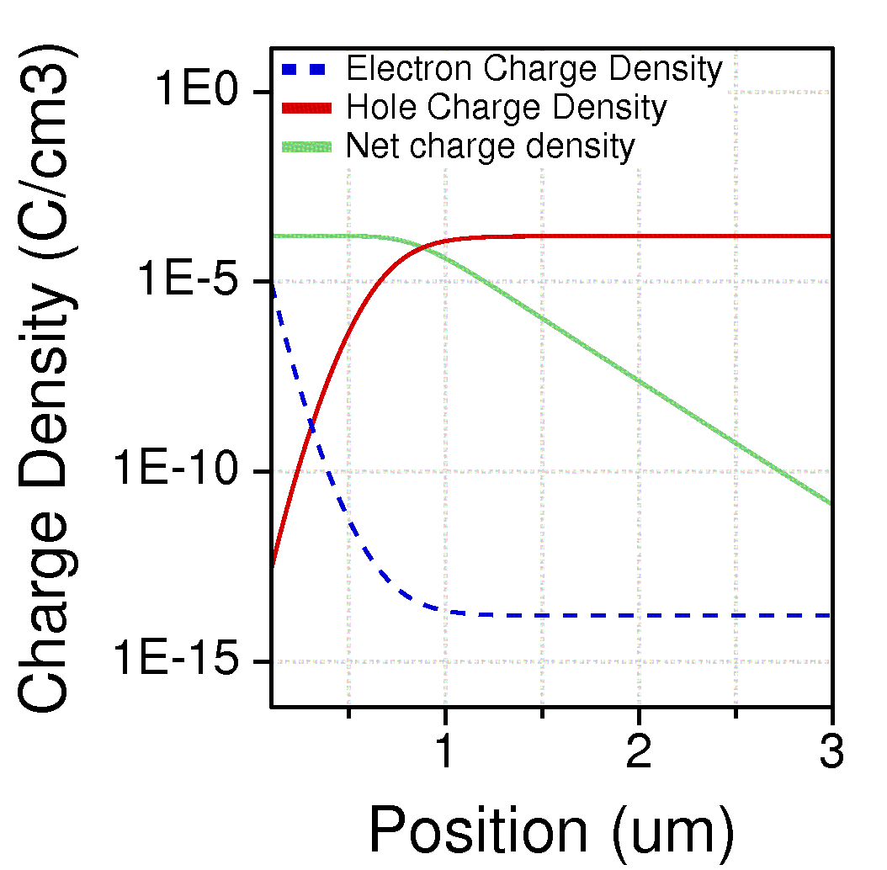

(iii) Inversion (V_{G}=5V)

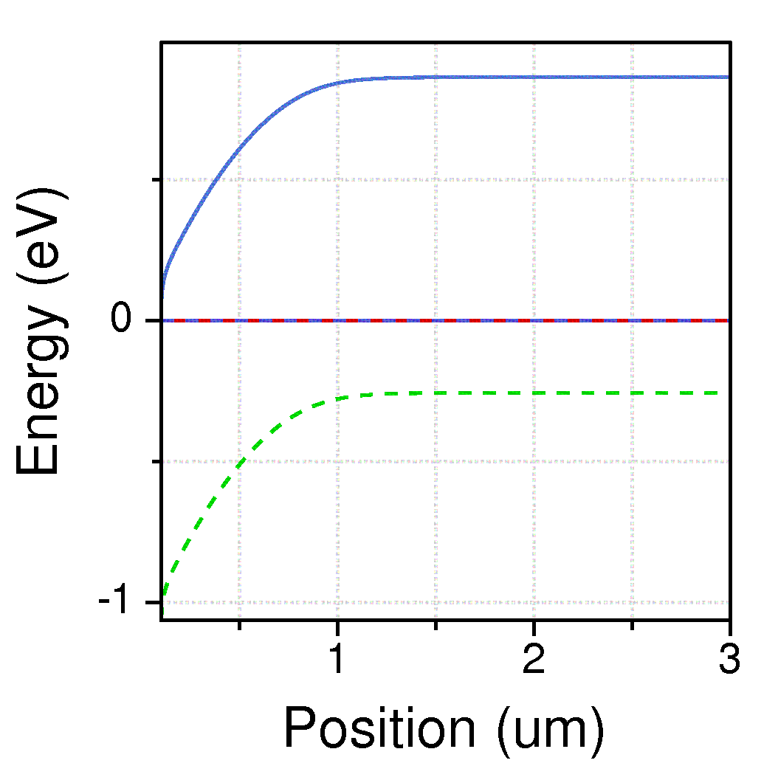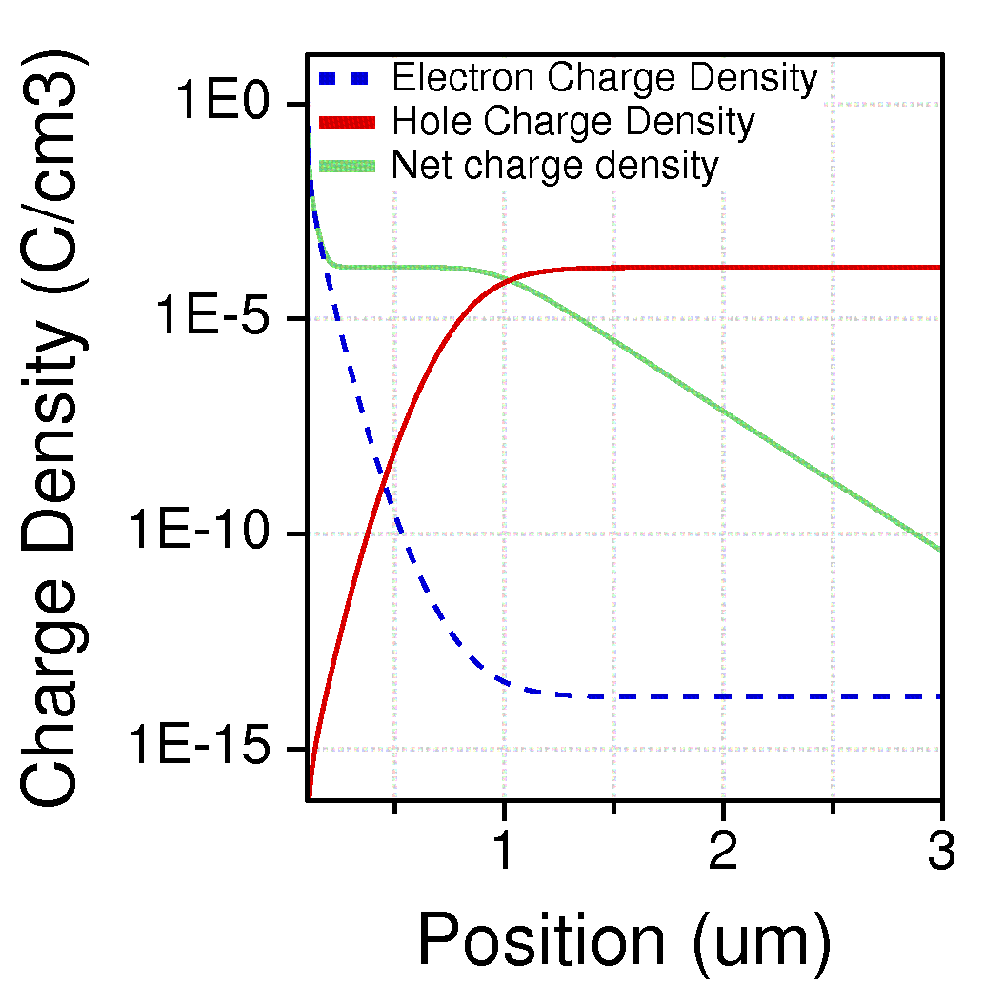

c) Analytically maximum attainable depletion width,
$$W_{T}=\sqrt{2∅_{F}\left(\frac{2K_{s}ϵ_{0}}{qN_{A}}\right)}=0.894 μm$$
Numerically W_{T} can be estimated from net charge figure in 2(ii). W_{T} is observed to be ~ 0.7 µm (distance at which net charge falls 10% of the maximum) which is close to analytical figure.

d)
