Verification of the validity of BJT lab
(http://nanohub.org/tools/bjt)
Saumitra R Mehrotra, Dragica Vasileska & Gerhard Klimeck
Simulation setup
We will validate results obtained from BJT Lab by comparing with analytical model. A pnp BJT in Common Base configuration is set up with the following parameters,
Base width, W_{B} = 2µm
Emitter region doping, N_{E} = 10¹⁸ /cm³
Base region doping, N_{B} = 10¹⁶ /cm³
Collector region doping, N_{C} = 10¹⁵ /cm³
Emitter region minority carrier lifetime, τ_{E} = 0.1µs
Base region minority carrier lifetime, τ_{B} = 1µs
Collector region minority carrier lifetime, τ_{C} = 0.1µs
- DC current gain, β parameter
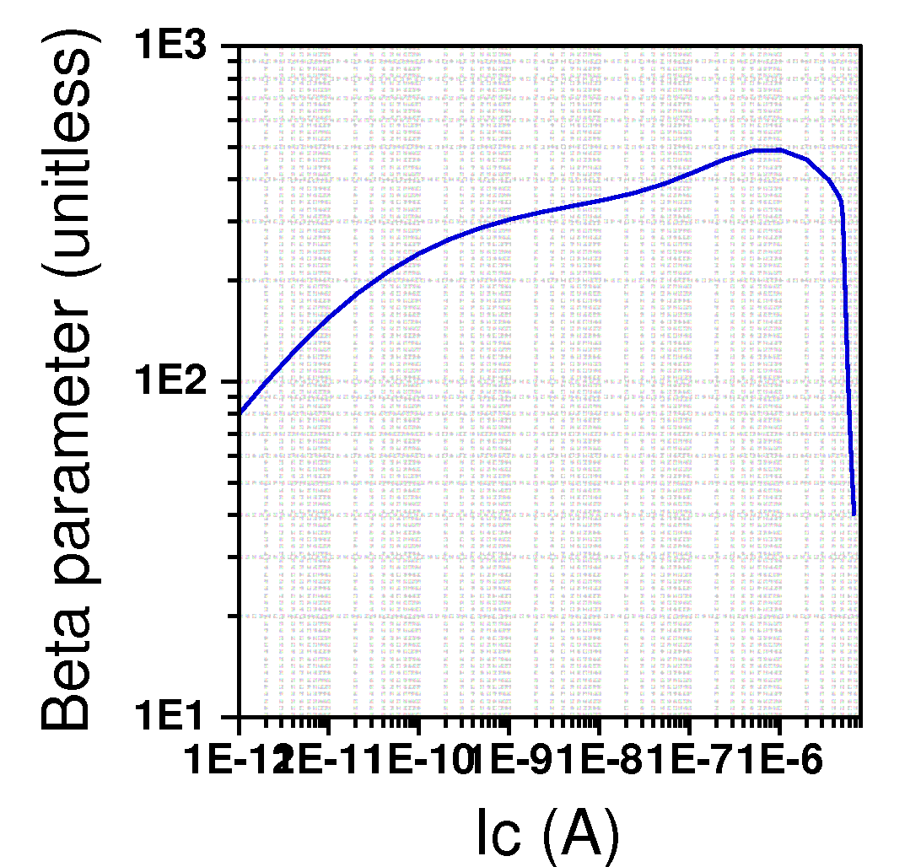
Figure 1 Beta parameter from BJT (www.nanohub.org/bjt)
Analytical calculation for β in W<<L_{B} limit.(Diffusion constant values from R.F Pierret, SDF pg 400, Table 11.1)
$$β=\frac{1}{\frac{D_{E}}{D_{B}}\frac{N_{B}}{N_{E}}\frac{W}{L_{E}}+\frac{1}{2}{\left(\frac{W}{L_{B}}\right)}^{2}}=310$$
Where D=Diffusion constant and L=Diffusion length.
- Output Characteristics
The output characteristics for pnp Common Base configuration BJT are calculated using Ebers-Moll model (MATLAB script given at the end).

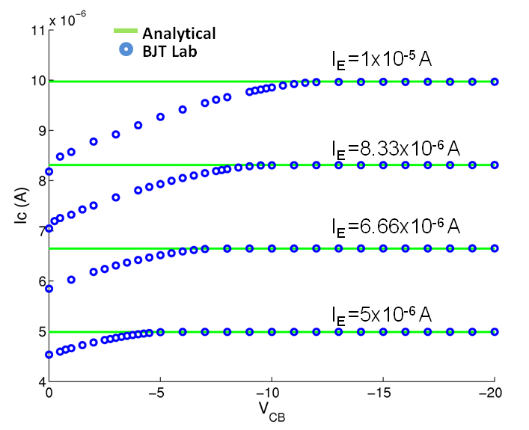
Figure 2 Comparison of analytical and numerical (BJT Lab) output characteristics of pnp BJT in CB mode

MATLAB script for analytical model
% Analytical solution for BJT PNP Common Base output characteristics
% for validation of BJT Lab (www.nanohub.org/tools/bjt)
% Author: Saumitra R Mehrotra

% Input Parameters
% Lifetime in s
TauE=1e-7; TauB=1e-6; TauC=1e-7;
% Doping in /cm3
NE=1e18; NB=1e16; NC=1e15;
% Length in cm
WB=2e-4;
% Mobility Parameters (from R.F. Pierret, Semiconductor Device Fundamentals pg. 777)
NDref=1.3e17; NAref=2.35e17;
unmin=92;upmin=54.3;
un0=1268; up0=406.9;
an=0.91;ap=0.88;
uE=unmin+un0./(1+(NE/NDref).^an);
uB=unmin+up0./(1+(NB/NAref).^ap);
uC=unmin+un0./(1+(NC/NDref).^an);
% Universal constants
k=8.617e-5; T=300; kT=k*T; ni=1e10; q=1.6e-19;
DE=kT*uE; DB=kT*uB; DC=kT*uC;
LE=sqrt(DE*TauE); LB=sqrt(DB*TauB); LC=sqrt(DC*TauC);
nE0=(ni^2)./NE; pB0=(ni^2)./NB; nC0=(ni^2)./NC;

% Ebers-Moll model
W=WB;
fB=(DB/LB)*pB0*(cosh(W/LB)/sinh(W/LB));
IF0=q*((DE/LE)*nE0+fB);
IR0=q*((DC/LC)*nC0+fB);
aF=q*(DB/LB)*(pB0/sinh(W/LB))/IF0;
aR=q*(DB/LB)*(pB0/sinh(W/LB))/IR0;
% Common Base output characteristics
Vcb=linspace(0,-20,40);
% Emitter injection current
Ie=linspace(5e-6,1e-5,4);
for ii=1:1:4
Ic(ii,:)=aF*Ie(ii)-(1-aF*aR)*IR0*(exp(Vcb/kT)-1);
end
hold on
plot(Vcb,Ic,'-g')

